 | BMS COLLEGE OF ENGINEERING, BANGALORE-19  (Autonomous Institute, Affiliated to VTU)  Department of Electronics and Communication
UNIT III Question Bank
Topics: Oscillators and Op-Amp

PART-I (REMEMBER/UNDERSTAND)
Key Words: name, list, describe, recognize, explain, summarize, Label, match
No. | Question | Marks
1 | What do you mean by electronic oscillator? Name the different types of oscillators. | 1+4
2 | Describe basic principle of oscillator with a block diagram? Is an external input signal necessary for the output of an oscillator? | 4+1
3 | Draw the circuit diagram of Hartley oscillator and explain its operation. | 2+3
4 | How sustained oscillations are produced in crystal oscillator and explain its operation with a diagram. | 3+2
5 | Explain RC phase shift oscillator with a neat circuit diagram and state any two applications of it. | 2+2+1
6 | Draw the equivalent circuit of crystal and explain the Piezoelectric property. Write the expressions for series parallel resonance frequencies. | 2+2+1
7 | Explain the block diagram of differential amplifier showing the four major stages, and list any four applications of Op-Amp | 3+2
8 | Draw the circuit of BJT differential amplifier and explain. Define CMRR and how it can be increased? | 3+2
9 | Explain the block of operational amplifier with a neat diagram. | 3+2
10 | - What is an Operational Amplifier?  - Mention four applications of Op-Amp  - Give four advantages of using Op-Amp | 1+2+2
11 | - State the characteristics of an Ideal Op-Amp  - How do the characteristics of a practical Op-Amp differ from those of the ideal Op-Amp? | 3+3
12 | Draw the circuit diagram of an Inverting amplifier using an Op-Amp. “A virtual ground exists at the input of the proper amplifier” - Explain | 2.5+2.5
13 | Draw the circuit of voltage follower and explain, Mention any two applications in communication. “The current entering into the Op-Amp is ideally zero”- Explain | 4+1+1
14 | Describe the operational amplifier as an integrator | 05
15 | Describe the operational amplifier as an differentiator | 05

PART-II (APPLY)
Key Words: derive, solve, develop, and obtain (maps to PO1)
No. | Question | Marks
1 | - The parameters of a crystal fitted in a crystal oscillator are as follows: L = 0.4H, C = 0.08pF, C₁ = 1pF and R = 6kΩ. Determine  - The series resonant frequency  - The parallel resonant frequency | 06+04
1 | - Estimate the values of R and C for an output frequency of 2kHz in a RC phase shift oscillator. | 06+04
2 | - What is the frequency of Hartley oscillator if the total inductance of L₁ and L₂ is 50mH and the capacitance of the resonant circuit is 200pF? | 04+06
2 | - In a phase shift oscillator that uses three RC sections, R_{L} = R = 10 kΩ. If the oscillator is to generate frequencies in the range from 1 to 100 kHz, what should be the range of C? | 04+06
3 | - The transistor RC phase shift oscillator has three RC sections with C = 0.01µF and R = 6.3 KΩ. If R_{L} = 4.7kΩ. Determine the frequency of oscillation. | 04+06
3 | - The equivalent electrical parameter of a crystal oscillator are L = 3H, C = 0.05pF, C_{P} = 6pF, and R = 1KΩ. Determine the series resonant frequency and the percentage by which the parallel resonant frequency exceeds the series resonance frequency. | 04+06
4 | - Derive the expression of the output of an Op-Amp Integrator with a neat circuit diagram. | 05+05
4 | - Draw the output waveform of an Op-Amp  - If square wave is given at the differentiator input.  - If triangular wave is given at the differentiator input | 05+05
5 | - For the following circuit , find the value of V_{o} with input resistance=1kΩ , Feedback resistance = 10KΩ and input voltage=2mV  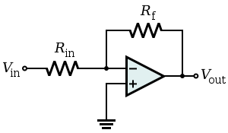 | 06+04
5 | - An Op-Amp non-inverting amplifier has an input resistance of 10KΩ and Feedback resistance of 50KΩ. If the input voltage is 0.5V, find the output voltage and input current. | 06+04
6 | - Derive the output expression of an operational amplifier as a summing amplifier and averaging circuit.  - Design an Op-Amp inverting amplifier of voltage gain -10 and input resistance 10KΩ. The circuit should amplify signals in the range -1.5V to +1.5V. What should be the minimum Op-Amp supply voltages? | 05+05
7 | - Derive how Operational Ampifier can be used as a subtracting device. | 06+04
7 | - For the following Op-amp circuit, R_{in} = 1000Ω and gain A = -75. Determine the value of feedback resistance.(V_{CC} = 12V and –V_{EE} = -12V). | 06+04
8 | - Consider an ideal Op-Amp circuit as shown in below figure. Given that R₁ = 10 KΩ, R_{f} = 30KΩ, V_{S} = 4V, find V_{o}  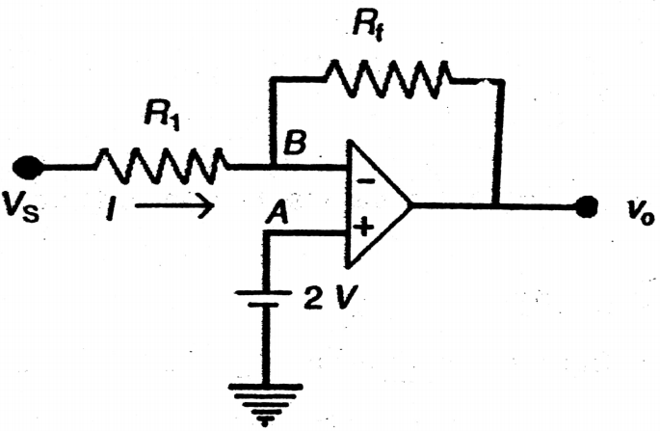 | 06+04
8 | - For the following Op-amp circuit, R_{g} = 12KΩ and gain A = 50. Determine the value of feedback resistance. (V_{CC} = 12V and –V_{EE} = -12V).  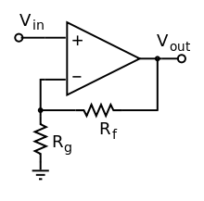 | 06+04
9 | - Derive the expression for output voltage of a differential amplifier | 05+05
9 | - The summing amplifier as shown in below figure has R_{f} = 10KΩ, R₁ = 10KΩ, R₂ = 2.2KΩ and R₃ = 3.3KΩ, If V₁ = 6V, V₂ = -3V, V₃ = -0.75V, Find V_{o}  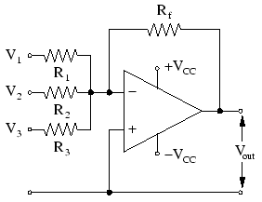 | 05+05
10 | - Determine the output voltage of a differential amplifier for input voltages of 320µV and 260µV. The differential gain of the amplifier is 4000 and the value of CMRR is 200 | 04+06
10 | - In the op-amp circuit shown below, evaluate V0 as a function of V₁, V₂ and V₃  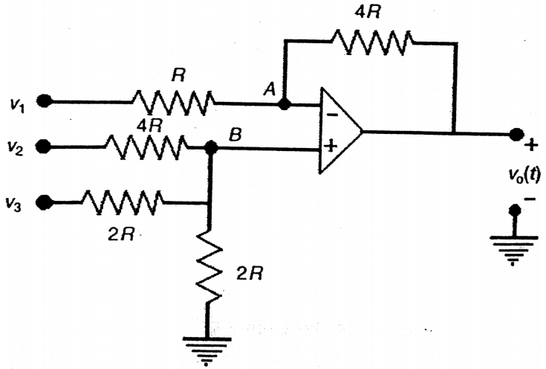 | 04+06
11 | - Derive the output expression of inverting and non-inverting amplifier | 06+04
11 | - A differential amplifier has a typical common mode gain of 40dB and CMRR of 80dB. Find the output voltage V_{o} when the input voltages are 0.20mV and 0.25mV. | 06+04
12 | - Consider the operational amplifier circuit as shown below. Assuming it to ideal the output voltage is given by V_{o} = A₁V₁+A₂V₂. Find the values of constants A₁ and A₂ for the resistor combination R₁ = 10KΩ, R₂ = 100KΩ, R₃ = 99KΩ.  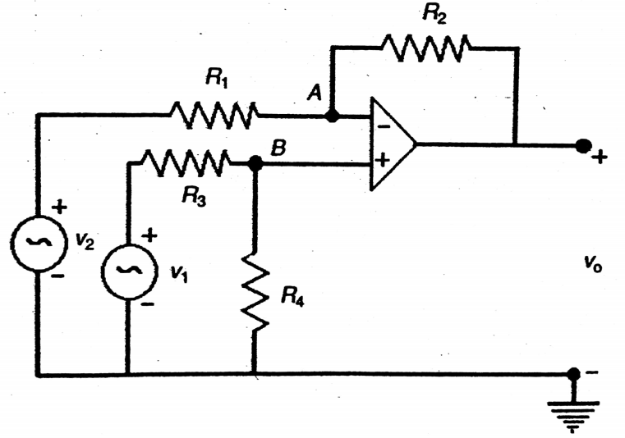 | 06+04
12 | - Derive the expression for output voltage of an Op-Amp differentiator with a diagram | 06+04

PART-III (DESIGN/ANALYZE/ENGINEERING TOOL/ANY OTHER)
ANALYSE: conclude, classify, infer, execute, maximize, minimize,
(Questions from GATE/IES/CAT/any other)
DESIGN: build, model, design
No. | Question | Marks
1 | Design an inverting summer using op-amp with the resistance values of Rf=90KΩ, R1=1KΩ, R2=10KΩ and R3=100kΩ. Calculate its output voltage in terms of its input voltages V1, V2 and V3. | 05
2 | Design an Op-Amp circuit to provide an output of Vo= - [3V1+1/2V2]. | 05
3 | Calculate the output voltage of the circuit shown in figure, if V1= - 0.2V and V2=0V.  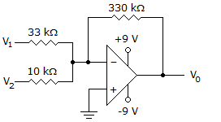 | 05
4 | Determine the output voltage for the circuit shown in figure with a sinusoidal input of 2.5 mV.  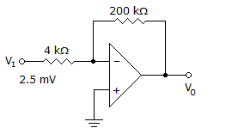 | 05
6 | Calculate the output voltage of the circuit shown in figure, if V1 = 300 mV and V2 = 700 mV. Also mention about how the op-amp is configured.  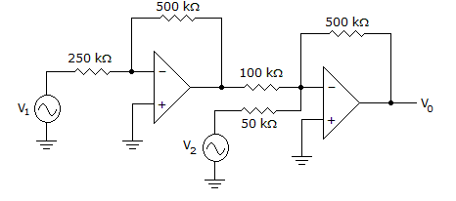 | 05
8 | Calculate the output voltage Vo for the circuit shown in figure, if V1 = –V2 = 300 mv 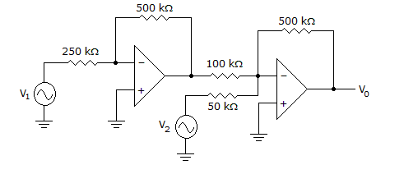 | 05
9 | Identify the circuit shown in figure. When a sine wave of 1vpeak at 1000Hz is applied to the circuit with the following specification: R_{F} =1kΩ and C1=0.33µF, find its output waveform and its output equation.  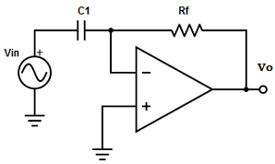 | 05
10 | Choose the value of RF and C for a 5kHz input signal to obtain good differentiation.  a) RF = 1.6×10³Ω, C1 = 33×10⁻⁶F  b) RF = 1.6×10³Ω, C1 = 0.47×10⁻⁶F  c) RF = 1.6×10³Ω, C1 = 47×10⁻⁶F  d) RF = 1.6×10³ Ω, C1 = 10×10⁻⁶F.Also justify your answer with calculation. | 05
11 | Design an appropriate circuit using Op-amp, whose input and output signals relations are as shown in figure. Also justify your answer with relevant equations.  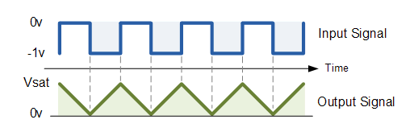 | 05
12 | Design a single op-amp circuit that performs amplified average function with a gain of 10. Draw the circuit diagram and clearly mark all the resistors values. | 05

