 | BMS COLLEGE OF ENGINEERING, BANGALORE-19  (Autonomous Institute, Affiliated to VTU)  Department of Electronics and Communication
UNIT III Solution
Topics: Oscillators and Op-Amp

PART-I (REMEMBER/UNDERSTAND)
Key Words: name, list, describe, recognize, explain, summarize, Label, match
No. | Question | Marks
1 | What do you mean by electronic oscillator? Name the different types of oscillators. What classes of oscillators are commonly used in AF and RF ranges and why?  Ans:  - Oscillators are electronic circuits that generate an output signal without the necessity of an input signal.  - It produces a periodic waveform on its output with only the DC supply voltage as an input.  - The output voltage can be either sinusoidal or nonsinusoidal, depending on the type of oscillator.  - Different types of oscillators produce various types of outputs including sine waves, square waves, triangular waves, and sawtooth waves.  Oscillators are circuits that generate a continuous voltage output waveform at a required frequency with the values of the inductors, capacitors or resistors forming a frequency selective LC resonant tank circuit and feedback network. This feedback network is an attenuation network which has a gain of less than one ( β <1 ) and starts oscillations when Aβ >1 which returns to unity ( Aβ =1 ) once oscillations commence.  There are basically types of Oscillators  1. Sinusoidal Oscillators – These are known as Harmonic Oscillators and are generally a LC Tuned-feedback or RC tuned-feedback type Oscillator that generates a purely sinusoidal waveform which is of constant amplitude and frequency.  2. Non-Sinusoidal Oscillators – These are known as Relaxation Oscillators and generate complex non-sinusoidal waveforms that changes very quickly from one condition of stability to another such as Square-wave, Triangular-wave or Saw tooth-wave type waveforms.  The classes of oscillators which are commonly used in AF range is RC tuned-Oscillator  and RF range is LC tuned-Oscillator | 1+2+2
2 | Describe basic principle of oscillator with a block diagram? Is an external input signal necessary for the output of an oscillator?  Ans:  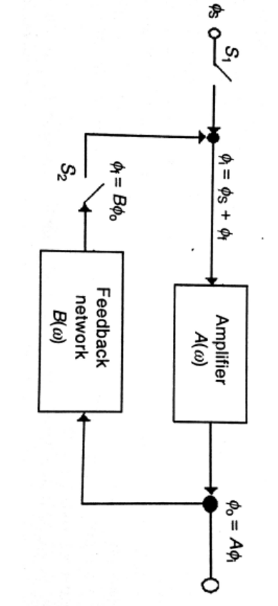  The block diagram of a basic sinusoidal oscillator consists of an amplifier A(w), and a frequency selective network (feedback network) B(w) connected in a positive feedback loop, is as shown in the above figure.  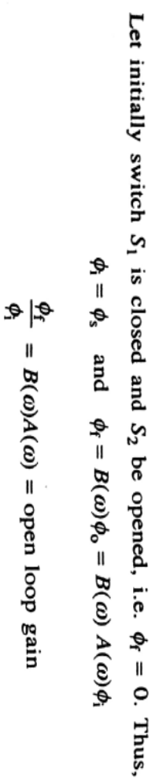  Here both A and B are functions of frequency. If for a particular frequency, w=w_{0,} we have,  A(w₀)B(w₀)=1, and from above equation, we get  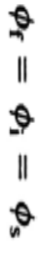  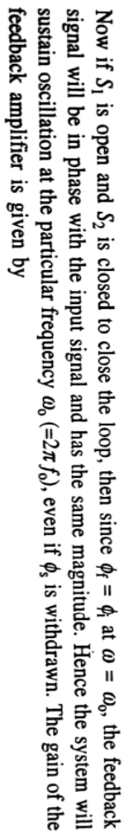  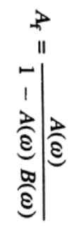  No. An external input signal is not necessary for the output of an oscillator | 4+1
3 | Draw the circuit diagram of Hartley oscillator and explain its operation.  Ans:  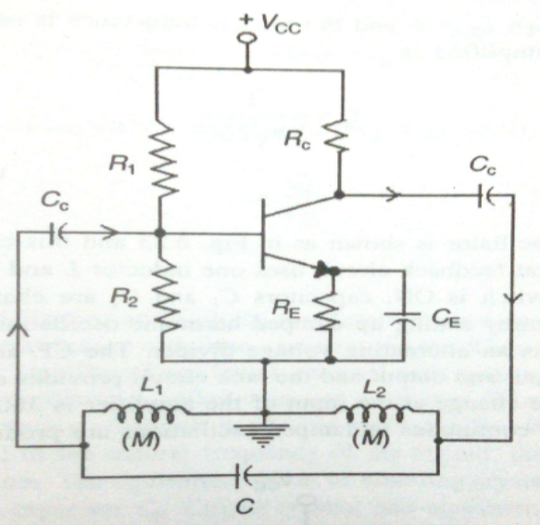  The Hartley oscillator is similar to the Colpitts except that the feedback circuit consists of two series inductors and a parallel capacitor as shown in Figure  - In this circuit, the frequency of oscillation for Q > 10 is  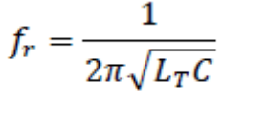  .where L_{T} = L₁+L₂ | 2+3
4 | How sustained oscillations are produced in crystal oscillator and explain its operation with a diagram.  Ans:  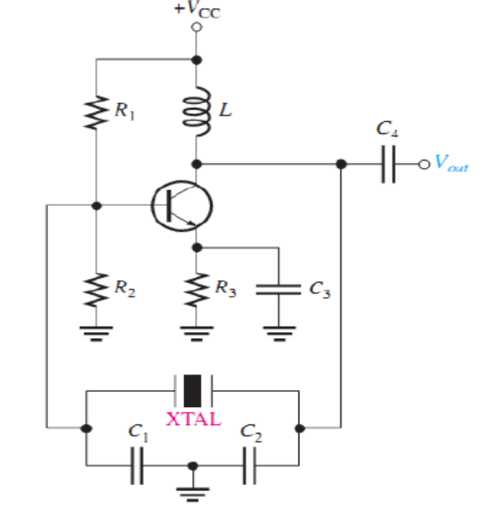  - The most stable and accurate type of feedback oscillator uses a piezoelectric crystal in the feedback loop to control the frequency. | 3+2
5 | Explain RC phase shift oscillator with a neat circuit diagram and state any two applications of it.  Ans:  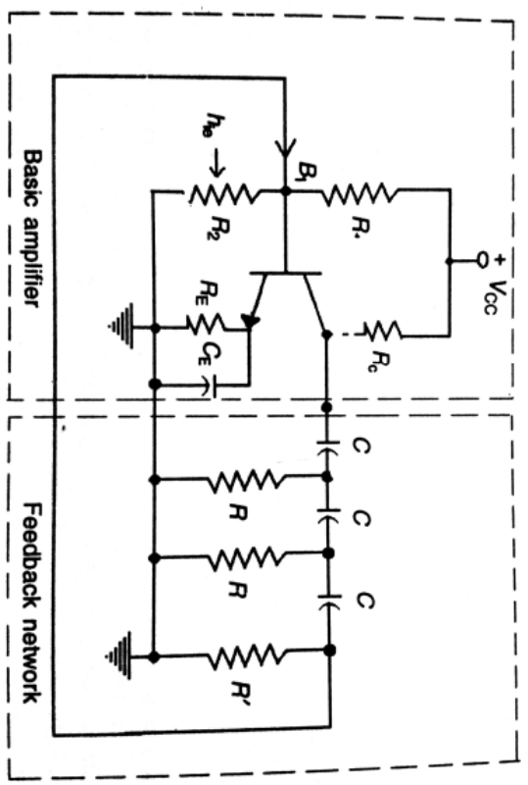  - Figure shows a sinusoidal RC phase-shift oscillator.  - Each of the three RC circuits in the feedback loop can provide a phase shift of 60°.  - Oscillation occurs at the frequency where the total phase shift through the three RC circuits is 180°.  - The inversion of the op-amp itself provides the additional 180° to meet the requirement for oscillation of a 360° (or 0°) phase shift around the feedback loop.  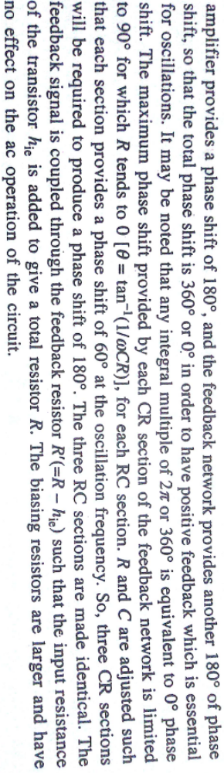  RC oscillators are used in numerous applications like as a local oscillator for synchronous receivers, transmitter, study purposes, musical instruments etc.  -The frequency of oscillation is given as  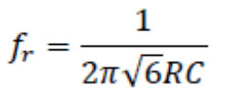 | 2+2+1
6 | Draw the equivalent circuit of crystal and explain the Piezoelectric property. Write the expressions for series parallel resonance frequencies.  Ans:  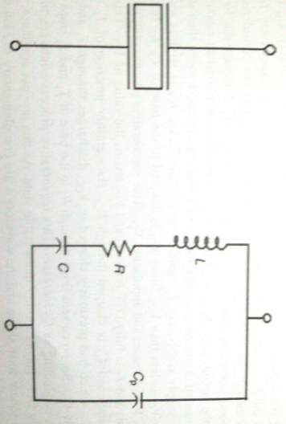  - Quartz is one type of crystalline substance found in nature that exhibits a property called the piezoelectric effect.  - When a changing mechanical stress is applied across the crystal to cause it to vibrate, a voltage develops at the frequency of mechanical vibration.  - Conversely, when an AC voltage is applied across the crystal, it vibrates at the frequency of the applied voltage.  - The greatest vibration occurs at the crystal’s natural resonant frequency, which is determined by the physical dimensions and by the way the crystal is cut.  - Series resonance frequency fs is given by  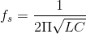  - Parallel resonance frequencies fp is given by  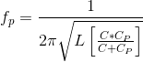 | 2+2+1
7 | What is the range of frequencies of normal operation of crystal oscillator? What is meant by frequency stability of an oscillator? Why the frequency stability of an oscillator is high when a piezoelectric crystal is used?  Ans: Few kHz to 100 MHz are the available range of frequencies of normal operation of crystal oscillator. | 1+2+2
8 | Explain the block diagram of differential amplifier showing the four major stages, and list any four applications of Op-Amp  - Differential amplifier (difference amplifier)  - Inverting amplifier  - Non-inverting amplifier  - Voltage follower (unity buffer amplifier)  - Summing amplifier  - Instrumentation amplifier  - A to D Converters  - Zero Crossing Detector (ZCD) | 3+2
9 | Draw the circuit of BJT differential amplifier and explain. Define CMRR and how it can be increased?  Ans:  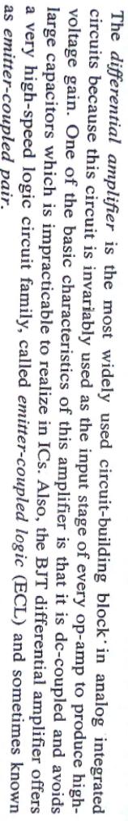  The Ability of a differential amplifier to reject a common-mode signal is defined by its common-mode rejection ratio [CMRR] and is known as the ‘figure of merit’ of a differential amplifier. It is expressed as the ratio of the differential gain Ad to the common-mode gain  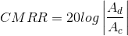  The effectiveness of rejecting the common-mode signal depends on the degree of matching of the two common emitter stages forming the differential amplifier | 3+2
10 | Explain the block of operational amplifier with a neat diagram.  Ans:  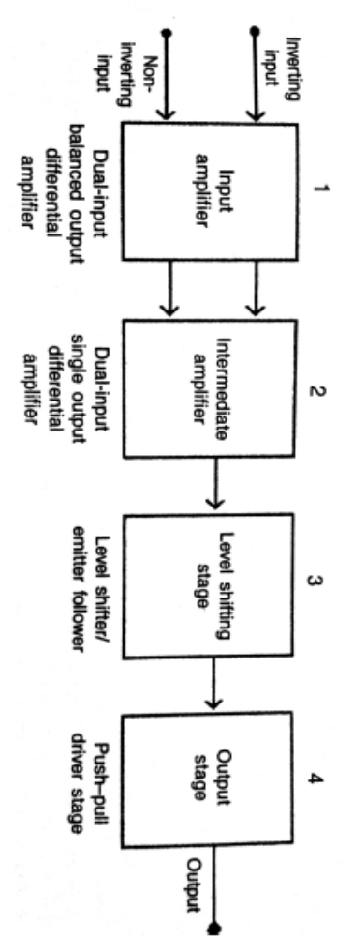  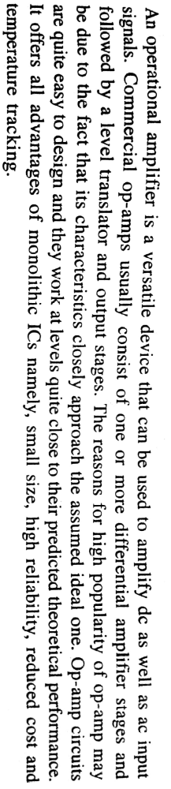  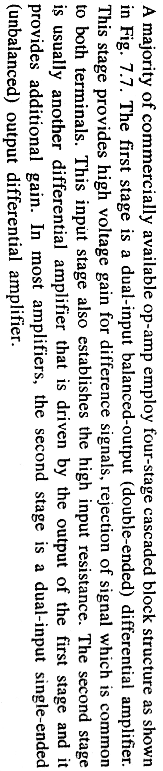 | 3+2
11 | - What is an Operational Amplifier?  Answer: An Operational Amplifier is a versatile device that can be used to amplify DC as well as AC input signals. Commercial Operational Amplifier usually consists of one or more differential amplifier stages and followed by a level translator and output stages. | 1+2+2
11 | - Mention four applications of Op-Amp.  Answer:  - Differential amplifier (difference amplifier)  - Inverting amplifier  - Non-inverting amplifier  - Voltage follower (unity buffer amplifier)  - Summing amplifier  - Instrumentation amplifier  - A to D Converters  - Zero Crossing Detector (ZCD) | 1+2+2
11 | - Give four advantages of using Op-Amp  - increased circuit stability,  - increased input impedance,  - decreased output impedance,  - increased frequency bandwidth at constant gain  - An op-amp is a high-gain amplifier that has high input impedance and low output impedance.  - An ideal op-amp has infinite gain and input impedance and zero  output impedance.  - An integrated circuit (IC) contains a number of components on a single piece of semiconductor. | 1+2+2
12 | - State the characteristics of an Ideal Op-Amp  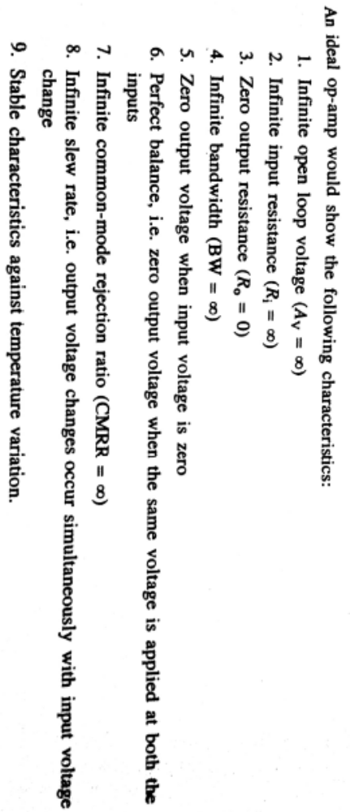 | 3+3
12 | - How do the characteristics of a practical Op-Amp differ from those of the ideal Op-Amp?  Ideal Op-Amp V/s practical Op-Amp  Ideal op-amps  - Infinite open-loop gain  - Infinite bandwidth  - Infinite slew rate  - Infinite input impedance and so zero input current  - Zero input offset voltage  - Zero output impedance  - Zero noise  - Infinite Common-mode rejection ratio (CMRR)  practical op-amps  - Finite open-loop gain  - Finite bandwidth  - Finite slew rate  - Finite input impedance and so a little input current  - Small input offset voltage  - Small output impedance  - Small noise  - Finite Common-mode rejection ratio (CMRR) | 3+3
13 | Draw the circuit diagram of an Inverting amplifier using an Op-Amp. “A virtual ground exists at the input of the proper amplifier” - Explain  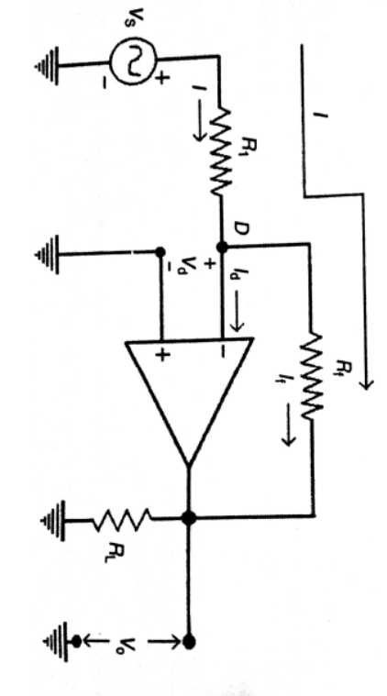  The inverting op amp has the input signal connected to its inverting input and the non-inverting input of the inverting op amp circuit is grounded. One assumption made is that the input error voltage is zero, so the feedback keeps inverting the input of the op amp at a virtual ground (not actual ground but acting like ground). The current flow in the input leads is assumed to be zero, hence the current flowing through R_{f} equals the current flowing through R₁. Using Kirchoff’s law, we write Equation and the minus sign is inserted because this is the inverting input.  virtual ground  A virtual ground exists at the input of the proper op amp is as shown in the figure.  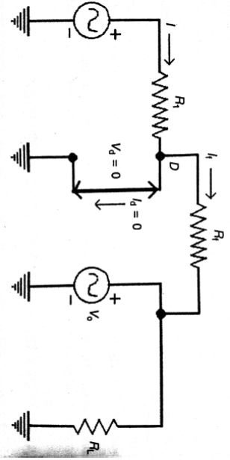 | 2.5+2.5
14 | Draw the circuit of voltage follower and explain, Mention any two applications in communication. “The current entering into the Op-Amp is ideally zero”- Explain  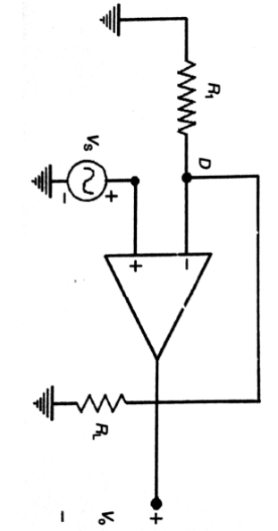  Answer: An Op-Amp having unity gain, very high-input resistance and large bandwidth is known as a voltage follower. In a voltage follower, the output is equal to and inphase to the input, that is the output follows input.  Application: 1) As Buffer Amplifier  2) Impedance matching  3) Isolation Amplifier | 4+1+1
15 | Describe the operational amplifier as an integrator and differentiator  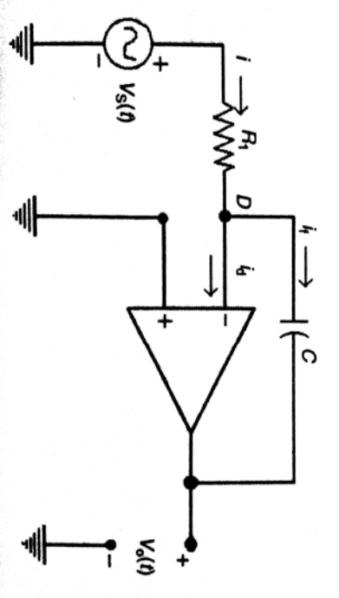  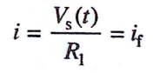  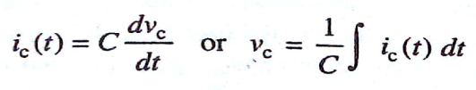  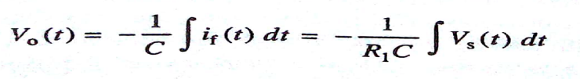 | 06  (03+03)
16 | Describe the operational amplifier as an differentiator  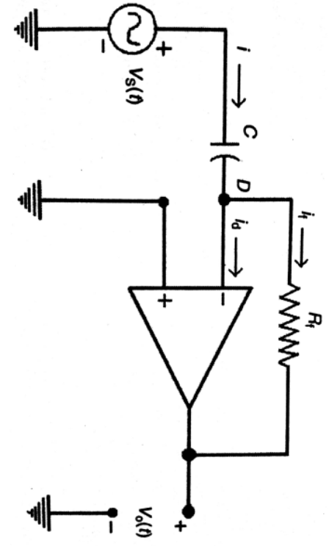  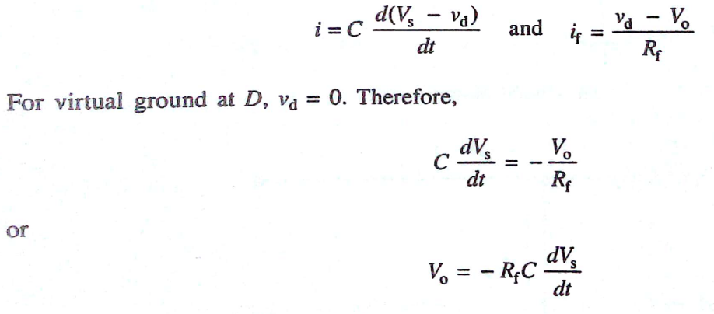 | 06  (03+03)

PART II (APPLY)

- a) i) f_{s} = $\frac{1}{2π\sqrt{LC}}$ = 889.70kHz ………………………………………………..(2M)

ii) f_{p} = $\frac{1}{2π\sqrt{LC_{eq}}}$ = 924.606kHz ……………….(2M) $C_{eq}= \frac{CC_{1}}{C+C_{1}}$ = 7.4X10⁻¹⁴ F………….(2M)

- b) Let R = 1kΩ
f= $\frac{1}{2π\sqrt{6}RC}$………………………….(2M)
C = $\frac{1}{2π\sqrt{6}Rf}$
C = 32.42nF………………………….(2M)

- a) C = 200pF
L1+L2= 50mH f = $\frac{1}{2π\sqrt{L_{eq}C}}$………………………(2M)
f= 50.329kHz…………………….(2M)
b) R_{L} = R = 10kΩ
f = 1 to 100kHz f = $\frac{1}{2π\sqrt{6}RC}$…………………………..(2M)
C = 6.49nF for f = 1KHz………..(2M)
C = 64.97pF for f = 10KHz……..(2M)
- a) f = $\frac{1}{2π\sqrt{6}RC}$………………………………………………………….(2M)
f = 1.031kHz………………………………………………………(2M)

b) f_{s} = $\frac{1}{2π\sqrt{LC}}$ = 410.936kHz ………………………………………………..(2M)

f_{p} = $\frac{1}{2π\sqrt{LC_{eq}}}$ = 412.644kHz ……………….(2M) $C_{eq}= \frac{CC_{1}}{C+C_{1}}$ = 4.95810⁻¹⁴ F………….(1M)
% increase in f_{p} over f_{s} = $\frac{f_{p- f_{s}}}{f_{s}}X100$ = 0.4156%............................(1M)

- a) Op-amp integrator is a circuit in which output voltage is integration of the input signal.
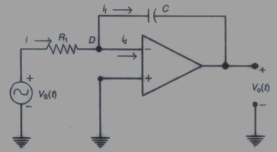……………..(2M)
Applying KCL at node D we obtain I = i_{d} + i_{f}, Assume Virtual ground at D and i_{d} = 0, i = i_{f}
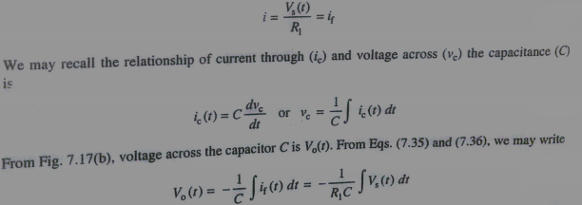……(3M)

b) i)
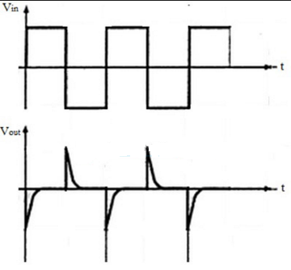…………………….(2.5M)

ii)
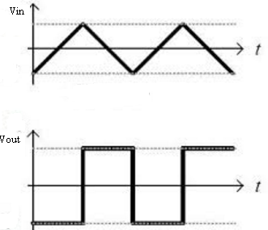………………………….(2.5M)

- a) V_{out} = -(R_{f}/R_{in})V_{in}……………………………………..(2M)
V_{out} = -20mV……………………………………………(2M)

b) V_{out} = (1+ R_{f}/R_{in}) V_{in}
V_{out} = 3.5V……………………………………………..(3M)
I_{in} = (0.5-0)/(10X10³)
I_{in} = 50µA……………………………………………….(3M)

- a)
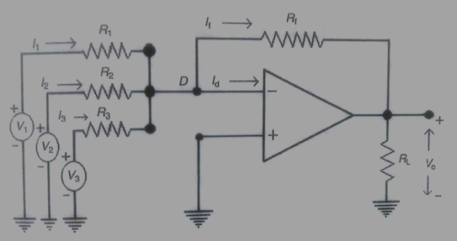……………..(2M)

The inverting amplifier configuration is used to add three input signals V1,V2 and V3. Resistances R1,R2 and R3 are connected with these signal sources respectively.Applying KCL at node D
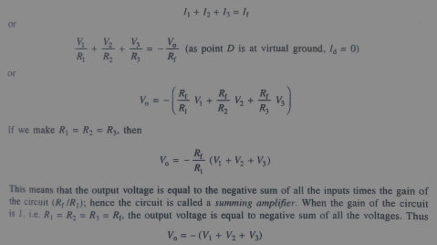…………..(2M)
The circuit can be used as averaging circuit in which output voltage will be average of input voltages. This can be accomplished by using all input resistances of equal value and gain is adjusted such that.
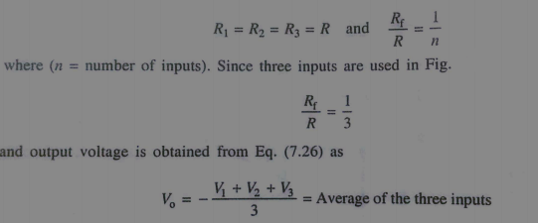………….(1M)
b) V_{in} = -1.5V, V_{out} = +15V
V_{in} = 1.5V, V_{out} = -15V……………………………….(1M)
A_{INV} = -(R_{f}/R_{in})
R_{f} = 100kΩ……………………………………………….(2M
Minimum powersupply = ±15V………………….(1M)
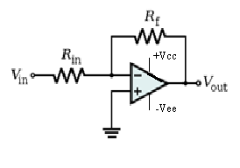………………….(1M)

- a) Difference of two signals V1 and V2 is amplified
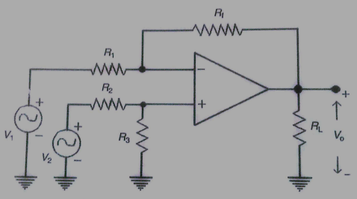…………………(3M)

Linear superposition theorem is used to find Vo, Initially consider V1 is present and output is Vo1, then V2 is considered the output will be Vo2, then overall output is Vo = Vo1 +Vo2
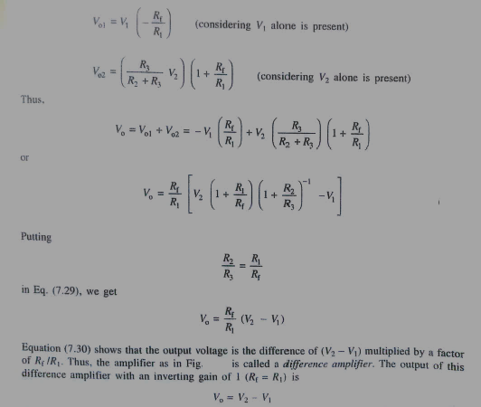……………….(3M)

b) V_{out} = -(R_{f}/R_{in})V_{in} ……………………………………(2M)
R_{f} = 75kΩ……………………………………………….(2M)

- a) Applying superposition theorem
Vs=0V Vo1 = (1+ R_{f}/R_{in}) V_{in} = 8V………………………………………………(2M)
Vs≠0V but 2Vsupply is zero Vo2 = -(R_{f}/R_{in})V_{in} = -12V………………….(2M)
Vo = Vo1+Vo2 = 8-12 = -4V………………………………………………………….(2M)

b) A_{NON-INV} = (1+ R_{f}/R_{in})……………………………………(2M)
R_{f} = 588kΩ………………………………………………….(2M)

- a)
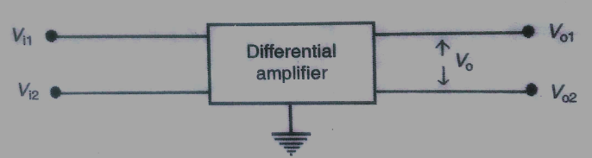…………………..(1M)
Two signals are defined one is difference mode signal Vd and other is common mode signal Vc.
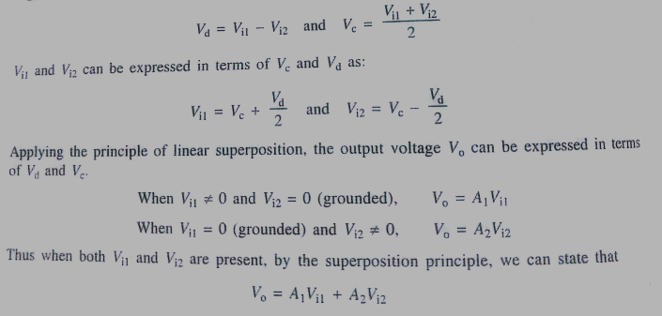
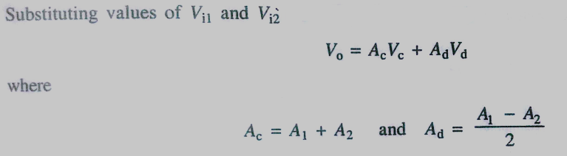……………(4M)

b) V_{out} = -((R_{f}/R₁)V₁ + (R_{f}/R₂)V₂ + (R_{f}/R₃)V₃) …………………………………………..(2.5M)
V_{out} = -9.9V……………………………………………………………………………………….(2.5M)

- a) V1 = 320µV
V2 = 260µV
Vc = (V1+V2)/2 = 290 µV………………………………………………………………………(1M)
Vd = (V1-V2) = 60 µV…………………………………………………………………………….(1M)
CMRR = Ad/Ac Ac = 20…………………………………………………………………………(1M)
V0 = (AdVd)+(AcVc)………………………………………………………………………………….(1M)
V0 = 245.8mV

b) Applying superposition theorem
i. V1 ≠ 0 and V2 = V3 = 0 V01 = -(R_{f}/R₁)V₁ = -4V1…………..(1M)
ii. V2 ≠ 0 and V1 = V3 = 0 V02 = (1+4R/R)(potential at B) = (1+4R/R)(V2/5) = V2………….(2M)
iii. V3 ≠ 0 and V1 = V0 = 0 V03 = (1+4R/R)(potential at B) = (1+4R/R)(2V3/5) = 2V3……….(2M)

V0 = V01+V02+V03 = -4V1+V2+2V3……….(1M)

- a) Inverting Amplifier
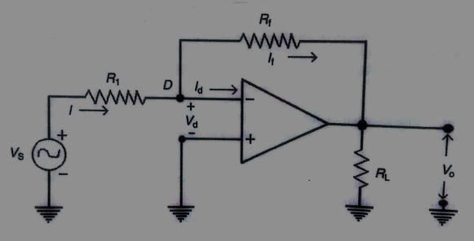……………….(1.5M)
The point D is at virtual ground, Id = 0 and Vd = 0, From the circuit
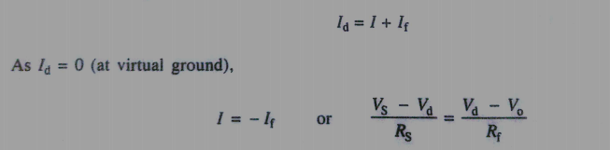
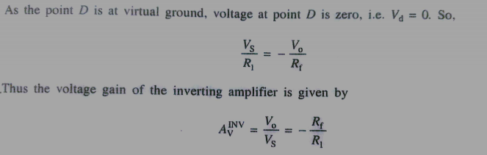…………(1.5M)

Non inverting Amplifier
V1 = Vd +Vs
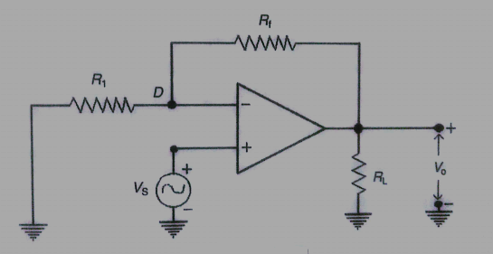……………..(1.5M)
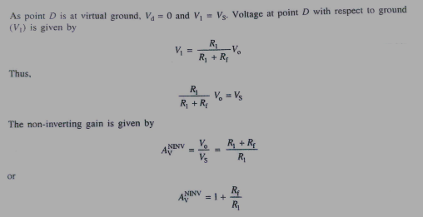.........(1.5M)

b) Ac = 40dB
CMRR = 80dB
V1 = 0.2mV
V2 = 0.25mV
20 log Ac = 40, Ac = 100
20 log CMRR = 80, CMRR = 10000……………………………(1M)

CMRR = Ad/Ac
Ad = 1000000
Vc = (V1+V2)/2 = 0.225mV………………………….(1M)
Vd = V1-V2 = -0.05mV………………………………….(1M)
Vo = (AdVd)+(AcVc)……………………………………….(1M)
Vo = -49.977V

- a) Applying superposition theorem
V2 ≠ 0 and V1 = 0 Vo1 = (-R2/R1)V2
Vo1 = -10V2……………………………………………………………………….(2M)
V1 ≠ 0 and V2 = 0 Vo2 = (1+R2/R1)(Potential at point B)
Vo2 = (1+R2/R1)(0.9074V1)
Vo2 = 9.98V1………………………………………………………………………(3M)

Vo = 9.98V1-10V2………………………………………………………………………………………………(6M)
A1 = 9.98
A2 = -10

b) 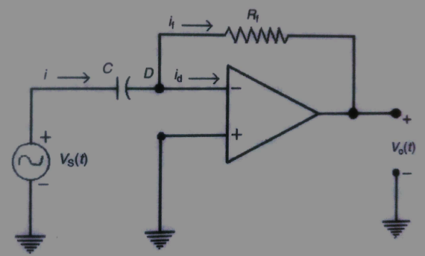
………….(2M)
This circuit performs mathematical operation of differentiation, node point D is at virtual ground. Since Id = 0,I=If

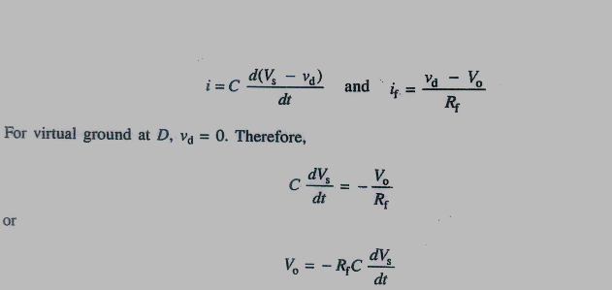………..(2M)

Part III
Question No 1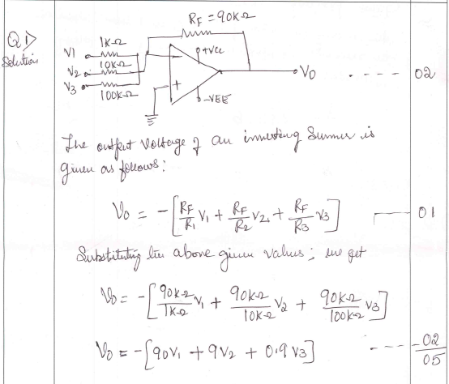
Question No 2
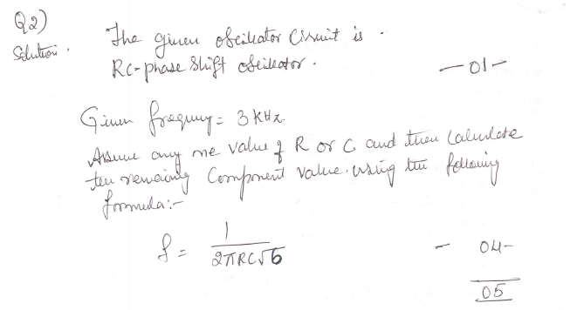
Question No 3
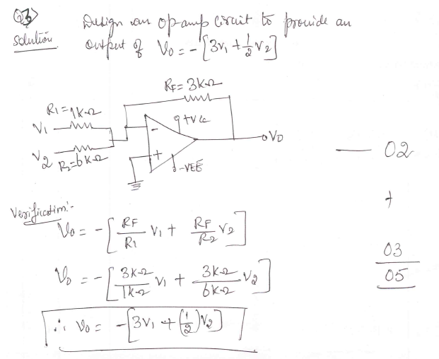

Question No 4
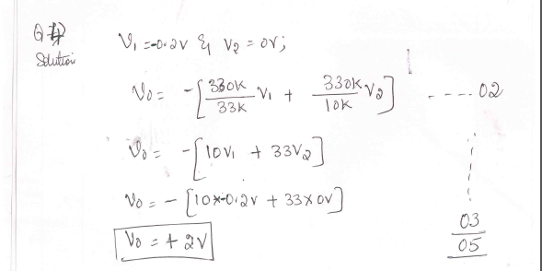
Question No 5
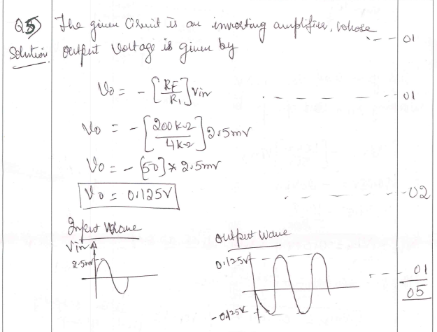
Question No 6
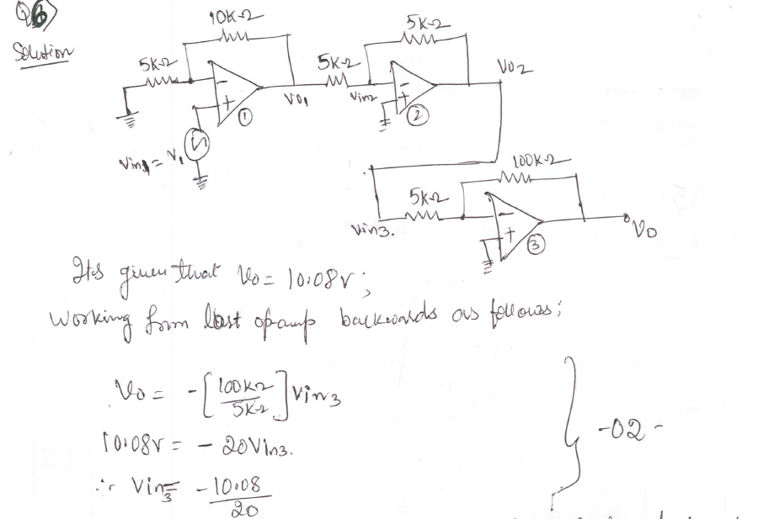
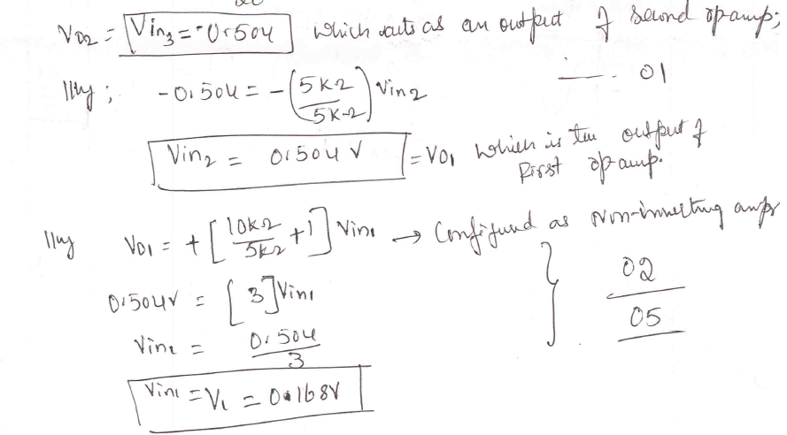
Question No 7
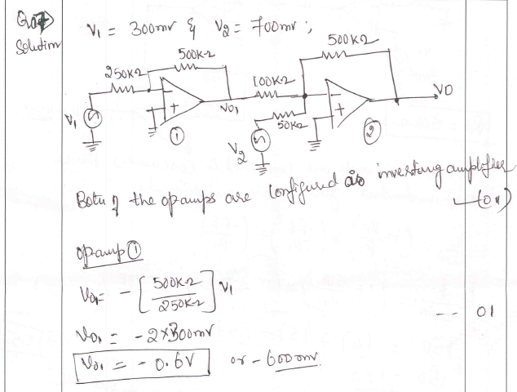
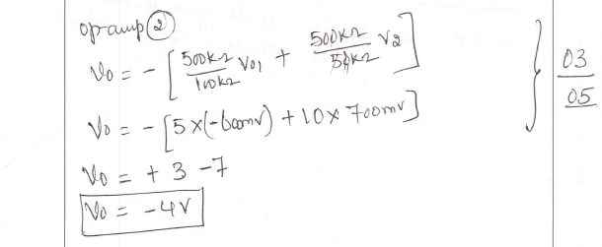
Question No 8
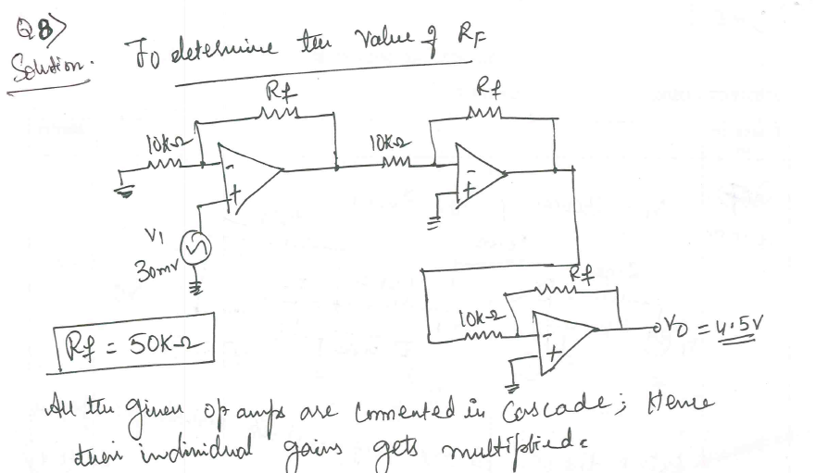
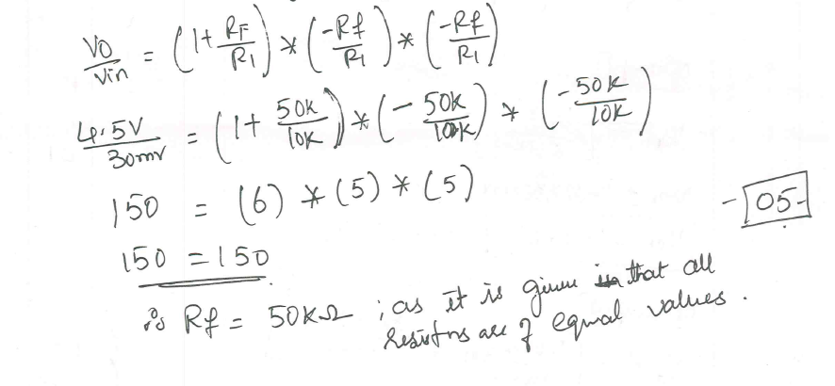
Question No 9
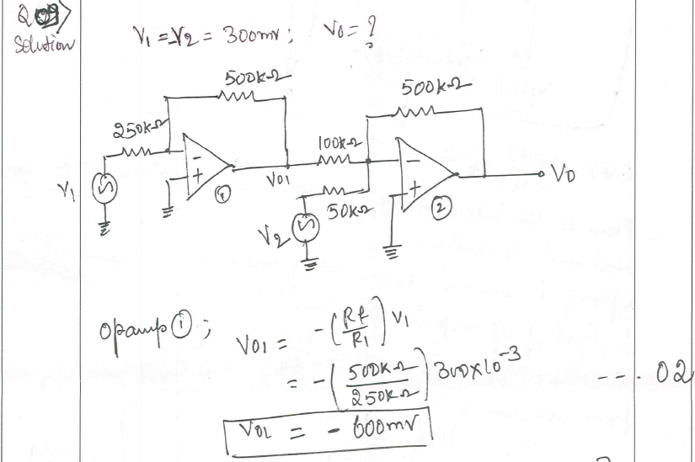
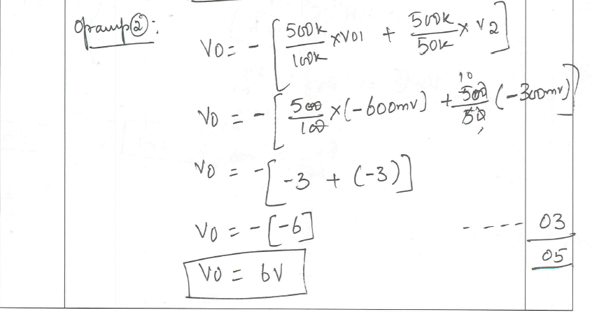
Question No 10 cancelledQuestion No 11
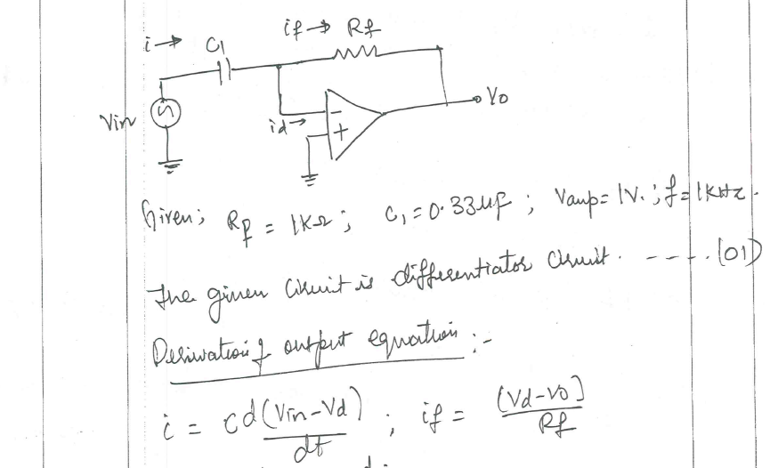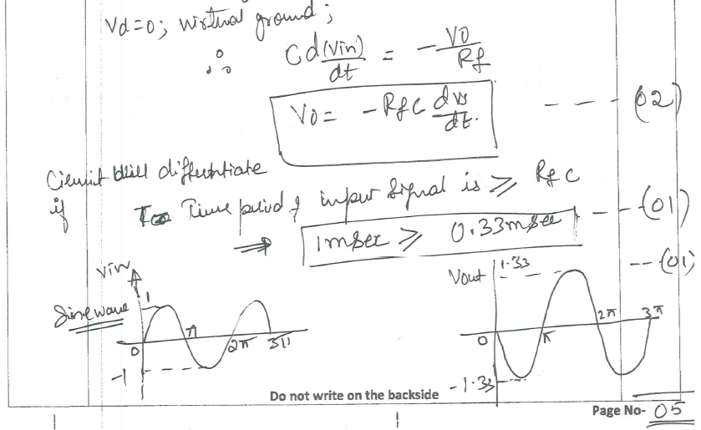

Question No 12

Question No 13

Question No 14
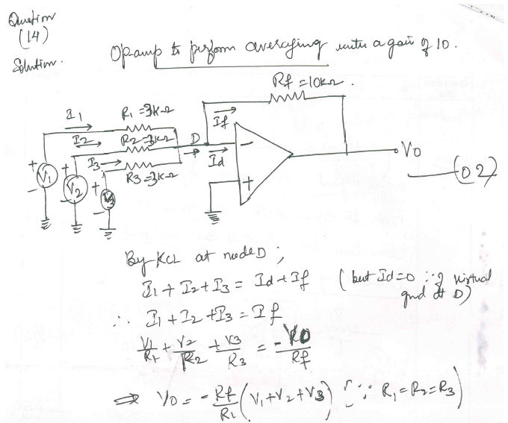
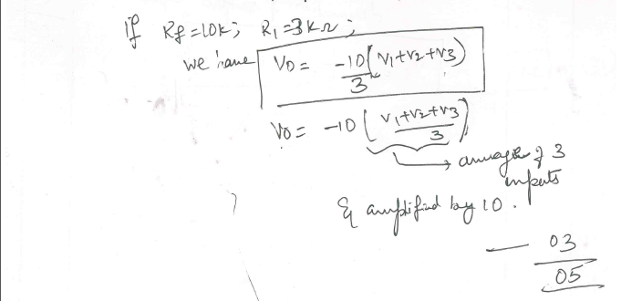

Question No 15

Question No 16

