Elements of Electronics Engineering
Unit – 2
- With a neat diagram, explain the operation of an NPN transistor.
- With a neat diagram, explain the input and output characteristics of a transistor in common emitter configuration.
- With a neat diagram, explain the input and output characteristics of a transistor in common base configuration.
- With a neat diagram, explain the input and output characteristics of a transistor in common collector configuration.
- What is a DC load line? Explain with a fixed bias (base bias) circuit diagram. Also explain the importance of the bias point/Q-point/operating point.
- What is meant by biasing of a transistor? With a neat diagram explain different modes in which transistor can be biased.
- What is bias stabilization? List causes for bias instability.
- Deduce the relationship between various Transistor current and also 𝛼 and 𝛽 of a transistor. In a common emitter transistor circuit, if β = 100 and IB = 50μA, compute the values of α, IE and IC.
- A voltage divider bias circuit has VCC=15V, RC=2.7kΩ, RE=2.2kΩ, R1=22kΩ, R2=12kΩ and β=50. Calculate VE, VC, IC and VCE and also draw DC load line and mark the Q-point. Assume VBE=0.7V.
- Determine emitter voltage VE , base voltage VB , Collector current Ic and VCE , with VBE = 0.7V, for a voltage divider bias circuit .Also draw the Load line and mark the Q point, if Vcc = 18V, R1 = 33kΩ , Rc=1.2kΩ, R2 = 12 kΩ, and RE = 1 kΩ.
- With a neat diagram derive equations for IC and VCE of voltage divider bias circuit using approximate analysis. If VCC=15 V, RC=900Ω, RE=900Ω, R1=6.8kΩ, R2=3.3kΩ, determine approximate levels of IC and VCE.
- With a neat diagram derive equations for IC and VCE of voltage divider bias circuit using precise analysis. Accurately analyze voltage divider bias circuit with supply of 25V, RC=4.7kΩ, RE=3.3kΩ, R1=33kΩ, R2=12kΩ and β=50 to determine Q-point.
- For the voltage divider bias circuit with Vcc =22V, Rc = 10KΩ, R1 = 37KΩ, R2 = 3.9KΩ, RE = 1.5KΩ, β = 160, Solve for DC bias voltage VCE and current Ic .If the transistor is replaced by β = 50, Determine new Q points, Assume Silicon transistor. Compare and Comment on result.
- When the transistor operates in CE configuration, the base current is 20µA. The collector current has changed from 4.5mA to 4.7mA. If the collector-emitter voltage is changed from 8.2V to 11.5V, determine the output resistance, α and β.
- Calculate α and β if IC is measured as 1mA and base current is 25µA. Also determine the new base current to give IC of 5mA.
- A emitter current of transistor in Common base configuration is IE=25mA and IC=23mA. Calculate base current, common base dc current gain and common emitter dc current gain.
- For the voltage divider bias circuit, determine IB, IC, VCE, VC, VE, VB. Supply voltage is 20V and resistor values are R1=18.6KΩ, R1=11.4KΩ ,RC=1 KΩ and RE=1 KΩ. Assume transistor with β=50.
- In voltage divider bias circuit shown below VCC =20V, RC=2.7kΩ, RE=1.8kΩ, R1=8.2kΩ, R2=2.2kΩ and β=120. Determine VC and VB.
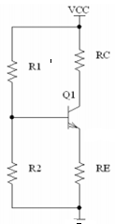
- For a voltage divider bias circuit with IB=40µA, RC=2kΩ, RE=1kΩ, VCC=10V and R2=10kΩ, determine (a) IC and VE (b) VC and VCE (c) VB and R1. Assume silicon transistor with β=80.
- The following current measurements are made on transistor: IC= 12.42mA, IB= 200µA. Determine a new IC level when IB is 150 µA.
- Accurately analyze voltage divider biasing circuit, with a supply of 25V, RC= 4.7KΩ, RE=3.3KΩ, R1= 33KΩ and R2=12KΩ and β=50.determine the levels of IC and VCE.
- A voltage divider biasing circuit has VCC=15V, RC=2.7KΩ, RE=2.2KΩ, R1= 22KΩ and R2=12KΩ calculate the Ic and Vce level through approximate analysis
- Design a voltage divider bias circuit to operate from 12V supply. The bias conditions are VCE=3V, VE=5V, and IC = 1mA. Assume VBE=0.7V.
- Identify the following V-I characteristics and comment on operation of circuit used to get same.
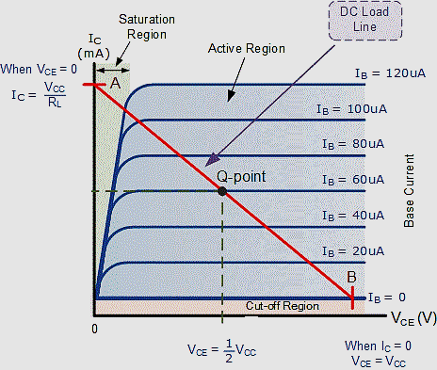
- Design a Voltage Divider Bias for the following parameters: Vcc=24V, Ic=5mA, VE=0.1VCC, VC= 0.55VCC and β=135.
- Briefly explain the any two advantages of negative feedback systems.
- With the help of a graph explain the frequency response of a BJT amplifier.
- Explain the working of CE Amplifier.
- Explain the significance of gain sensitivity for an open loop system and a system with feedback.
- Define feedback system, and Mention its type along with gain with feedback expression.
- List the advantages of –ve feedback system.
- If the output power from an audio amplifier is measured at 10W when the signal frequency is 1kHz and 1W when the signal frequency is 10kHz. Calculate the dB change in power.
- The voltage amplifier has maximum voltage gain of 400. Find the gain at cut-off frequency in dB.
- The gain of the amplifier is 40. If positive feedback is introduced with gain of 0.025 estimate the gain of the amplifier with feedback. Also estimate gain of the amplifier with feedback If negative feedback is introduced with gain of 0.025
- An amplifier has a bandwidth of 500Khz and voltage gain of 100.What should be the amount of negative feedback if the bandwidth is extended to 5Mhz?What will be the new gain after negative feedback is introduced?
- An amplifier has midband gain of 125 and a bandwidth of 250KHz. If 4% negative feedback is introduced, find the new bandwidth and gain. If bandwidth is restricted to 1MHz, find the feedback ratio.
- Analyze the following graph and explain its significance.
