PART I (UNDERSTAND AND REMEMBER)

- With a neat diagram, explain the operation of an NPN transistor. 5M
Principle of operation of NPN transistor

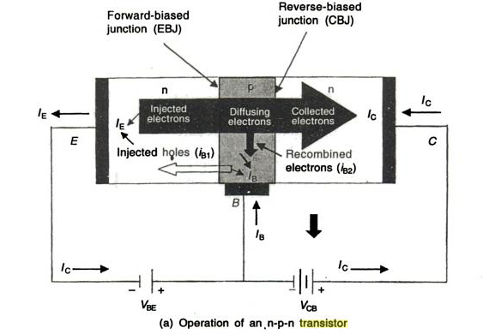

Figure (a) shows an idealized NPN bipolar transistor biased in the forward-active mode.
- An NPN bipolar transistor biased in the forward-active mode means base–emitter junction forward biased and base–collector junction reverse biased.
- Since the E-B junction is forward biased, as a result depletion region narrows ,electrons from the emitter are injected across the B–E junction into the base, this constitute emitter current I_{e}
- Since base is p-type and thin a very few electrons combine with holes in base, this constitute base current I_{b.}
- The remaining large number of electrons cross the base region and move through the collector region to the +ve terminal of the external dc source vcc, this constitute collector current I_{c}.
- Thus main current in an NPN transistor is due to electron flow.

- With a neat diagram, explain the input and output characteristics of a transistor in common emitter configuration. 5M
The characteristic of the common emitter transistor circuit is shown in the figure below. The base to emitter voltage varies by adjusting the potentiometer R₁. And the collector to emitter voltage varied by adjusting the potentiometer R₂. For the various setting, the current and voltage are taken from the milliammeters and voltmeter. On the basis of these readings, the input and output curve plotted on the curve.
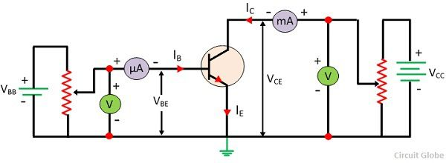

Input Characteristic Curve
The curve plotted between base current I_{B} and the base-emitter voltage V_{EB} is called Input characteristics curve. For drawing the input characteristic the reading of base currents is taken through the ammeter on emitter voltage V_{BE}at constant collector-emitter current. The curve for different value of collector-base current is shown in the figure below.
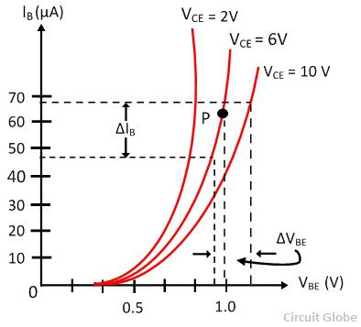
The curve for common base configuration is similar to a forward diode characteristic. The base current I_{B} increases with the increases in the emitter-base voltage V_{BE}. Thus the input resistance of the CE configuration is comparatively higher that of CB configuration.
The effect of CE does not cause large deviation on the curves, and hence the effect of a change in V_{CE} on the input characteristic is ignored.

Output Characteristic
In CE configuration the curve draws between collector current I_{C} and collector-emitter voltage V_{CE} at a constant base current I_{B} is called output characteristic. The characteristic curve for the typical NPN transistor in CE configuration is shown in the figure below.
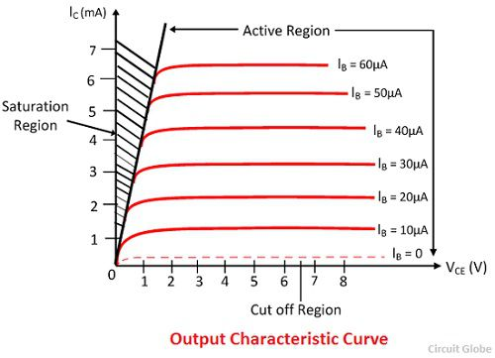
In the active region, the collector current increases slightly as collector-emitter V_{CE} current increases. The slope of the curve is quite more than the output characteristic of CB configuration. The output resistance of the common base connection is more than that of CE connection.
The value of the collector current I_{C} increases with the increase in V_{CE} at constant voltage I_{B}, the value β of also increases.
When the V_{CE} falls, the I_{C} also decreases rapidly. The collector-base junction of the transistor always in forward bias and work saturate. In the saturation region, the collector current becomes independent and free from the input current I_{B}
In the active region I_{C} = βI_{B}, a small current I_{C} is not zero.

- What is a DC load line? Explain with a fixed bias (base bias) circuit diagram. Also explain the importance of the bias point/Q-point/operating point. 5M
DC load line
- Dc load line for a transistor is o straight line drawn on output characteristics.
- For common emitter, the load line is line drawn on graph of Ic Vs V_{CE.}
- The load line shows all corresponding levels of Ic and V_{CE} that can exist in a particular circuit.
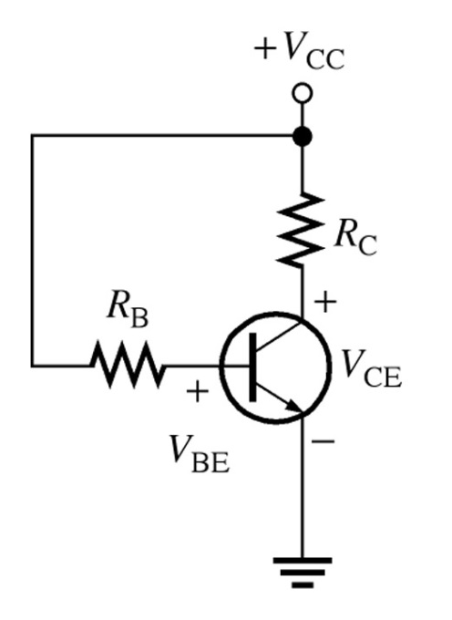
Consider the common emitter circuit as shown in the fig note that the polarities of the terminal voltages are such that base-emitter junction is forward biased and collector-base junction is reverse biased.
Applying KVL to output loop, we get
V_{CE=} Vcc –Ic Rc----------------------(1)
Substitute Ic=0 in eq 1,
V_{CE=} 20v –0* Rc = 20v (point A)
Plot point A on the C-E characteristics as shown at Ic=0 and Vcc=20v, one point of dc load line
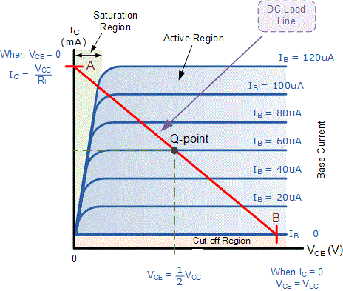
If Vce=0v in eq 1, then
0₌ 20v –Ic* 10
Ic=Vcc/Rc=20/10=2mA (point B)
Plot point B on the C-E characteristics as shown at Ic=2mA and Vcc=0v, another point of dc load line.
The Straight line drawn through A and B is dc load line for Rc=10KΩ and Vcc=20v.
If either of these 2 quantities changed, anew load line must be drawn.
Operating point (Q)
A point on the d.c. load line which represent the signal values of VCE and IC in a transistor is called as operating point or silent point or quiescent point or Q-point.
The Q-point is selected where the DC load line intersects the curve of output characteristics for particular value of signal current.
i.e. Q-point = (VCE ,IC)
- What is meant by biasing of a transistor? With a neat diagram explain different modes in which transistor can be biased. 5M
- Biasing is applying voltage to a junction.
- There are four possible ways of biasing these junctions
    - When emitter base junction is forward biased and CB junction is reverse biased the BJT is said to be in active mode. This mode is used if BJT is used to operate as an Amplifier
    - When both junctions are forward biased, BJT is said to be in saturation mode.
    - When both junctions are reverse biased, BJT is said to be in cut-off mode.
    - Switching applications use cut-off and saturation modes
    - When emitter base junction is reverse biased and CB junction is forward biased the BJT is said to be in Inversion mode or Reverse Active. Inversion mode is used in TTL gates.
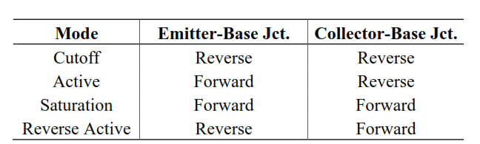

Active mode
E JE B JC C

p p

n

VEB VCB

Saturation mode
E JE B JC C

p p

n

VEB VCB

Cut-off mode
E JE B JC C

p p

n

VEB VCB

Inversion Mode E JE B JC C

p p

n

VEB VCB
- What is bias stabilization? List causes for bias instability. 5M

Bias stabilization
The process of making operating point independent of temperature changes or variation in transistor parameters is called the Bias stabilization.
We know that for transistor to operate it should be properly biased so that we can have a fixed operating point. To avoid any distortions, the Q-point should be at the center of the load line.
But in practice this Q-point may shift to any operating region (saturation or cur-off region) making the transistor unstable. Therefore in order to avoid this, biasing stability should be maintained.

Causes for shift of operating point or Bias instability

Bias instability occurs mainly due to two reasons.
- Temperature
- Current gain

1. Temperature (T)
The temperature at the junctions of a transistor depends on the amount of current flowing through it. Due to increase in temperature following parameters of a transistor will change.

(a) Base-emitter voltage (VBE)
VBE decreases at a rate of 1.8mV/0C with one degree rise in temperature for Si diode and VBE decreases at a rate of 2.02mV/0C with one degree rise in temperature for Ge diode.
The base current IB will increase if VBE decreases and since IC= βIB, IC will also increases resulting in changing the Q-point.

(b) Reverse saturation current (ICBO)
We know that IC = βIB + (1+β) ICBO where ICBO is the reverse saturation current. ICBO doubles for every 100C rise in temperature there by increase in IC and hence changing the Q-point.

2. Current gain (β)
In the process of manufacturing the transistors different transistors of same type may have different parameters ( i.e. if we take two transistor units of same type and use them in the circuit there is a change in the β value in actual practice ). The biasing circuit will be designed according to the required β value but due to the change in β from unit to unit the operating point may shift.
In summary increase in temperature always increases collector current Ic Because β and ICBO increase with temperature and VBE decreases with increase in temperature.

- Discuss the operation of transistor as a switch.5M
Transistor as a switch
A transistor acts as a switch as explained below

1. When the base emitter junction is open or reverse biased (i.e., I_{B}=0) no collector current(I_{C}) flows, the transistor is said to be OFF.
Even if I_{B}=0, I_{C=} I_{CEO}, which is very small and thus for practical purposes, the transistor is said to be non-conducting and is in OFF region.

Cut-off Characteristics
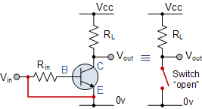 | • The input and Base are grounded ( 0v )  • Base-Emitter voltage V_{BE} < 0.7v  • Base-Emitter junction is reverse biased  • Base-Collector junction is reverse biased  • Transistor is “fully-OFF” ( Cut-off region )  • No Collector current flows ( I_{C} = 0 )  • V_{OUT} = V_{CE} = V_{CC} = ”1″  • Transistor operates as an “open switch”

2.When the base emitter junction is forward biased and I_{B} flows, as a result of which I_{C} flows and at some value of I_{B} , I_{C} becomes saturated, i.e., it does not increase further and becomes independent of I_{B}.at this point, the may be treated as fully ON as it is conducting in saturation region.

Saturation Characteristics
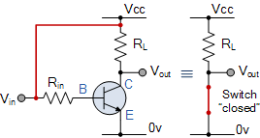 | • The input and Base are connected to V_{CC}  • Base-Emitter voltage V_{BE} > 0.7v  • Base-Emitter junction is forward biased  • Base-Collector junction is forward biased  • Transistor is “fully-ON” ( saturation region )  • Max Collector current flows ( I_{C} = Vcc/R_{L} )  • V_{CE} = 0 ( ideal saturation )  • V_{OUT} = V_{CE} = ”0″  • Transistor operates as a “closed switch”

The transistor can be made OFF, if I_{B} is reduced to zero.
The areas of operation for a Transistor Switch are known as the Saturation Region and the Cut-off Region. The transistor as a switch by driving it back and forth between its “fully-OFF” (cut-off) and “fully-ON” (saturation) regions as shown below.

Operating Regions
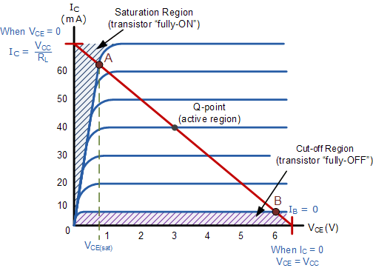The shaded area at the bottom of the curves represents the “Cut-off” region while the shaded area to the left represents the “Saturation” region of the transistor.

PART-II (APPLY)
SCHEME

1. Deduce the relationship between various Transistor current and also 𝛼 and 𝛽 of a transistor. In a common emitter transistor circuit, if β = 100 and I_{B} = 50μA, compute the values of α, I_{E} and I_{C}.

$I_{E}=I_{B}+I_{C}$
$I_{C}=α I_{E}$
$I_{E}=I_{C}/α$
$\frac{I_{C}}{α}= I_{B}+ I_{C}$
$I_{C}=\left(\frac{α}{1-α}\right)I_{B}=βI_{B}$
$I_{E}=\left(1+β\right)I_{B}$
---------7M
$I_{C}=βI_{B}=100*50μ=5mA$
$I_{E}=I_{B}+I_{C}=5m+50μ=5.05mA$
$α=\frac{β}{1+β}=\frac{100}{101}=0.99$
--------- 3M
2. A voltage divider bias circuit has V_{CC}=15V, R_{C}=2.7kΩ, R_{E}=2.2kΩ, R₁=22kΩ, R₂=12kΩ and β=50. Calculate V_{E}, V_{C}, I_{C} and V_{CE} and also draw DC load line and mark the Q-point. Assume V_{BE}=0.7V.

$V_{th}=\frac{V_{CC}R_{2}}{R_{1}+R_{2}}=5.294 V$ ----1M
$R_{th}=\frac{R_{1}R_{2}}{R_{1}+R_{2}}=7.7647KΩ$ ----1M

$I_{B}=\frac{V_{th}-V_{BE}}{R_{th}+(1+β)R_{E}}=38.294μA$ -----1M
$I_{C}=βI_{B}=1.9147mA$ -----1M
$I_{E}=\left(1+β\right)I_{B}=1.95mA$ ------1M
$V_{CE}=V_{CC}-I_{C}R_{C}-I_{E}R_{E}=15-\left(1.915m*2.7K\right)-\left(51*38.294μ*2.2K\right)=5.53 V$ ------1 M
Substituting $V_{CE}=0V, I_{C}=\frac{V_{CC}}{(R_{C}+R_{E)}}=3.06mA , If I_{C}=0mA,then V_{CE}=V_{CC}=15 V$ ----1M
$V_{E}=I_{E}R_{E}=4.29 V$ -----1M
$V_{C}=V_{CE}+V_{E}=9.82 V$ -----1M
Load line and Q-point diagram
I_{C}
V_{CE}
3.06mA
15 V
Q-point (V_{CE}, I_{C}) = (5.53V, 1.915mA)

------1M
3. Determine emitter voltage V_{E}, base voltage V_{B}, Collector current Ic and V_{CE}, with V_{BE} = 0.7V, for a voltage divider bias circuit. Also draw the Load line and mark the Q point, if Vcc = 18V, R₁ = 33kΩ, Rc = 1.2kΩ, R₂ = 12 kΩ, and R_{E} = 1 kΩ.
$V_{B}=\frac{V_{CC}R_{2}}{R_{1}+R_{2}}=4.8V$ ----1M
$V_{E}=V_{B}-V_{BE}=4.8-0.7=4.1 V$ ---1M
$I_{E}=\frac{V_{E}}{R_{E}}=4.1mA$ -----1M
$I_{C}=I_{E}=4.1mA$ -----1M

$V_{CE}=V_{CC}-I_{C}{(R}_{C}+R_{E})=18-4.1m\left(1.2K+1K\right)=8.98 V$ ------2 M
Substituting $V_{CE}=0V, I_{C}=\frac{V_{CC}}{(R_{C}+R_{E)}}=8.18mA , If I_{C}=0mA,then V_{CE}=V_{CC}=18 V$ ----2M
Load line and Q-point diagram
I_{C}
V_{CE}
8.18mA
18 V
Q-point (V_{CE}, I_{C}) = (8.98V, 4.1mA)

------2M

4. With a neat diagram derive equations for I_{C} and V_{CE} of voltage divider bias circuit using approximate analysis. If V_{CC}=15V, R_{C}=900Ω, R_{E}=900Ω, R₁=6.8kΩ, R₂=3.3kΩ, determine approximate levels of I_{C} and V_{CE}.

Circuit diagram
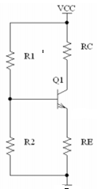 ------ 2M

$V_{B}=\frac{V_{CC}R_{2}}{R_{1}+R_{2}}=4.9V$ ----2M
$V_{E}=V_{B}-V_{BE}=4.9-0.7=4.2 V$ ---1M
$I_{E}=\frac{V_{E}}{R_{E}}=4.667mA$ -----1M
$I_{C}=I_{E}=4.667mA$ -----1M

$V_{CE}={V_{CC}-I_{C}R_{C}{-I_{E}R}_{E}=V}_{CC}-I_{C}{(R}_{C}+R_{E})=15-4.667m\left(900+900\right)=6.6 V$ ------3 M

6. With a neat diagram derive equations for I_{C} and V_{CE} of voltage divider bias circuit using precise analysis. Accurately analyze voltage divider bias circuit with supply of 25V, R_{C}=4.7kΩ, R_{E}=3.3kΩ, R₁=33kΩ, R₂=12kΩ and β=50 to determine Q-point.
Circuit diagram
------ 2M
$V_{th}=\frac{V_{CC}R_{2}}{R_{1}+R_{2}}=6.667 V$ ----1M
$R_{th}=\frac{R_{1}R_{2}}{R_{1}+R_{2}}=8.8KΩ$ ----1M

$I_{B}=\frac{V_{th}-V_{BE}}{R_{th}+(1+β)R_{E}}=33.69μA$ -----2M
$I_{C}=βI_{B}=1.68mA$ -----1M
$I_{E}=\left(1+β\right)I_{B}=1.718mA$ ------1M
$V_{CE}=V_{CC}-I_{C}R_{C}-I_{E}R_{E}=25-\left(1.68m*4.7K\right)-\left(51*33.69μ*3.3K\right)=11.43 V$ ------2 M

7. For the voltage divider bias circuit with Vcc =22V, Rc = 10KΩ, R₁ = 37KΩ, R₂ = 3.9KΩ, R_{E} = 1.5KΩ, β = 160, Solve for DC bias voltage V_{CE} and current Ic .If the transistor is replaced by β = 50, Determine new Q points, Assume Silicon transistor. Compare and Comment on result.
For β = 160
$V_{th}=\frac{V_{CC}R_{2}}{R_{1}+R_{2}}=2.0978 V$ ----1M
$R_{th}=\frac{R_{1}R_{2}}{R_{1}+R_{2}}=3.528KΩ$ ----1M

$I_{B}=\frac{V_{th}-V_{BE}}{R_{th}+(1+β)R_{E}}=5.7046μA$ -----1M
$I_{C}=βI_{B}=0.9127mA$ -----1M
$I_{E}=\left(1+β\right)I_{B}=0.918mA$ ------1M
$V_{CE}=V_{CC}-I_{C}R_{C}-I_{E}R_{E}=22-\left(0.9127m*10K\right)-\left(161*5.7046μ*1.5K\right)=11.496 V$ --1 M

Q-point (I_{C}, V_{CE})= (0.9127mA,11.496V)

For β = 50
$I_{B}=\frac{V_{th}-V_{BE}}{R_{th}+(1+β)R_{E}}=17.466μA$ -----1M
$I_{C}=βI_{B}=0.873mA$ -----1M
$I_{E}=\left(1+β\right)I_{B}=0.891mA$ ------1M
$V_{CE}=V_{CC}-I_{C}R_{C}-I_{E}R_{E}=22-\left(0.873m*10K\right)-\left(51*17.466μ*1.5K\right)=11.93 V$ --1 M

New Q-point (I_{C}, V_{CE})= (0.873mA,11.93V)
Even though β changes, Q-point does not change much.

8. When the transistor operates in CE configuration, the base current is 20µA. The collector current has changed from 4.5mA to 4.7mA. If the collector-emitter voltage is changed from 8.2V to 11.5V, determine the output resistance, α and β.
$I_{B}=20μA$
$∆I_{C}=\left(4.7-4.5\right)mA=0.2mA$ ----1M
$∆V_{CE}=11.5-8.2=3.3 V$ ----1M
Output resistance $r_{0}=\frac{∆V_{CE}}{∆I_{C}}=16.5KΩ$ -----2M
$β_{1}=\frac{I_{C1}}{I_{B}}=225, β_{2}=\frac{I_{C2}}{I_{B}}=235$ ----2M
$I_{E1}=I_{C1}+I_{B}=4.52mA$
$I_{E2}=I_{C2}+I_{B}=4.72mA$ ----2M
$α_{1}=\frac{I_{C1}}{I_{E1}}=0.9955, α_{2}=\frac{I_{C2}}{I_{E2}}=0.9957$ ----2M
$$OR use α=\frac{β}{β+1}$$
9.a. Calculate α and β if I_{C} is measured as 1mA and base current is 25µA. Also determine the new base current to give I_{C} of 5mA.
b. A emitter current of transistor in Common base configuration is I_{E}=25mA and I_{C}=23mA. Calculate base current, common base dc current gain and common emitter dc current gain.
a$. β=\frac{I_{C}}{I_{B}}=40$ -----1M
$α=\frac{β}{β+1}=0.975$ -----2M
$I_{B}=\frac{I_{C}}{β}=\frac{5m}{40}=125μA$ ---2M
b. $α=\frac{I_{C}}{I_{E}}=\frac{23m}{25m}=0.92$ ---Common base current gain ----2M
Common emitter current gain $β=\frac{α}{1-α}=\frac{0.92}{1-0.92}=11.5$ ---2M
$I_{B}=\frac{I_{C}}{β}=\frac{23m}{11.5}=2mA$ ----1M
10. For the voltage divider bias circuit, determine I_{B}, I_{C}, V_{CE}, V_{C}, V_{E}, V_{B}. Supply voltage is 20V and resistor values are R₁=18.6KΩ, R₂=11.4KΩ ,R_{C}=1 KΩ and R_{E}=1 KΩ. Assume transistor with β=50.
$V_{th}=\frac{V_{CC}R_{2}}{R_{1}+R_{2}}=7.6V$ ----1M
$R_{th}=\frac{R_{1}R_{2}}{R_{1}+R_{2}}=7.068KΩ$ ----1M

$I_{B}=\frac{V_{th}-V_{BE}}{R_{th}+(1+β)R_{E}}=118.826μA$ -----1M
$I_{C}=βI_{B}=5.941mA$ -----1M
$I_{E}=\left(1+β\right)I_{B}=6.06mA$ ------1M
$V_{CE}=V_{CC}-I_{C}R_{C}-I_{E}R_{E}=20-\left(5.941m*1K\right)-\left(6.06m*1K\right)=7.999 V$ --2 M
$V_{E}=I_{E}R_{E}=6.06 V$ -----1M
$V_{C}=V_{CE}+V_{E}=14.059 V$ -----1M
$V_{B}=V_{BE}+V_{E}=0.7+6.06=6.76$ V ----1M

11. In voltage divider bias circuit shown below V_{CC} =20V, R_{C}=2.7kΩ, R_{E}=1.8kΩ, R₁=8.2kΩ, R₂=2.2kΩ and β=120. Determine V_{C} and V_{B}.

$V_{th}=\frac{V_{CC}R_{2}}{R_{1}+R_{2}}=4.23V$ ----1M
$R_{th}=\frac{R_{1}R_{2}}{R_{1}+R_{2}}=1.7346KΩ$ ----1M

$I_{B}=\frac{V_{th}-V_{BE}}{R_{th}+(1+β)R_{E}}=16.079μA$ -----1M
$I_{C}=βI_{B}=1.93mA$ -----1M
$I_{E}=\left(1+β\right)I_{B}=1.946mA$ ------1M
$V_{CE}=V_{CC}-I_{C}R_{C}-I_{E}R_{E}=20-\left(1.93m*2.7K\right)-\left(1.946m*1.8K\right)=11.29 V$ --2 M
$V_{E}=I_{E}R_{E}=3.5028 V$ -----1M
$V_{C}=V_{CE}+V_{E}=14.79 V$ -----1M
$V_{B}=V_{BE}+V_{E}=0.7+6.06=4.2 V$ ----1M

12. For a voltage divider bias circuit with I_{B}=40µA, R_{C}=2kΩ, R_{E}=1kΩ, V_{CC}=10V and R₂=10kΩ, determine (a) I_{C} and V_{E} (b) V_{C} and V_{CE} (c) V_{B} and R₁. Assume silicon transistor with β=80.
(a) $I_{C}=βI_{B}=80*40μ=3.2mA$
$V_{E}=I_{E}R_{E}=\left(1+β\right)R_{E}=81*40μ=3.24 V$ ----2M
(b) $V_{CE}=V_{CC}-I_{C}R_{C}-I_{E}R_{E}=10-\left(3.2m*2K\right)-\left(3.24m*1K\right)=0.36 V$
$V_{C}=V_{CE}+V_{E}=0.36+3.24=3.6 V$ ----2 M
(c) $V_{B}=V_{BE}+V_{E}=0.7+0.36=1.3 V$ ----1 M
$I_{B}=\frac{V_{th}-V_{BE}}{R_{th}+\left(1+β\right)R_{E}}=80μA=\frac{\frac{10}{1+\frac{10K}{R_{1}}}-0.7}{\left(\frac{10K}{1+\frac{10K}{R_{1}}}\right)+\left(81*1K\right)}$
$R_{1}=35.54KΩ$ ------5M

13. The following current measurements are made on transistor: I_{C}= 12.42mA, I_{B}= 200µA. Determine a new I_{C} level when I_{B} is 150 µA.
a.$I_{D}=I_{DSS}{\left(1-\frac{V_{GS}}{V_{P}}\right)}^{2}=15m*{\left(1-\frac{-6}{-7}\right)}^{2}=0.306mA$ -----3M
$g_{m}=g_{m0} \left(1-\frac{V_{GS}}{V_{P}}\right)=0.643mS$ ----3M
b. $β=\frac{I_{C}}{I_{B}}=\frac{12.42m}{200μ}=62.1$ ----2M
$I_{CNEW}=βI_{BNEW}=62.1*150μ=9.31mA$ ---2M

14. Accurately analyze voltage divider biasing circuit with a supply of 20V, R_{C}= 4.7KΩ, R_{E}=2.2KΩ, R₁= 33KΩ and R₂=12KΩ and β=100. Determine the levels of I_{C} and V_{CE} and draw the circuit of voltage divider bias circuit using Thevinins’s theorem..

$V_{th}=\frac{V_{CC}R_{2}}{R_{1}+R_{2}}=5.33V$ ----1M
$R_{th}=\frac{R_{1}R_{2}}{R_{1}+R_{2}}=1.7346KΩ$ ----1M

$I_{B}=\frac{V_{th}-V_{BE}}{R_{th}+(1+β)R_{E}}=20.67μA$ -----2M
$I_{C}=βI_{B}=2.067mA$ -----1M
$I_{E}=\left(1+β\right)I_{B}=2.088mA$ ------1M
$V_{CE}=V_{CC}-I_{C}R_{C}-I_{E}R_{E}=20-\left(2.067m*4.7K\right)-\left(2.088m*2.2K\right)=5.69 V$ --2 M
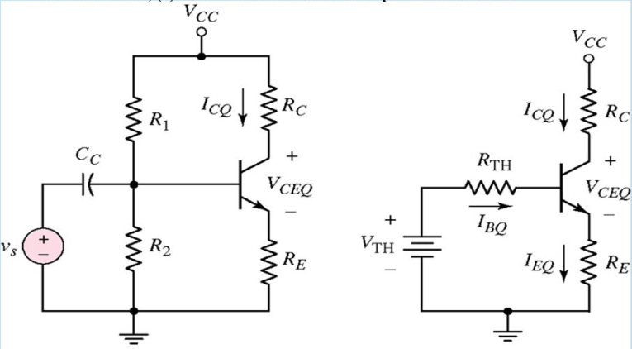 -----------2M

15. A voltage divider biasing circuit has V_{CC}=18V, R_{C}=4.7KΩ, R_{E}=2.2KΩ, R₁=22KΩ and R₂=10KΩ calculate the Ic and Vce level through approximate analysis along with neat circuit diagram.
Circuit diagram
------ 2M

$V_{B}=\frac{V_{CC}R_{2}}{R_{1}+R_{2}}=5.625V$ ----2M
$V_{E}=V_{B}-V_{BE}=5.625-0.7=4.925 V$ ---1M
$I_{E}=\frac{V_{E}}{R_{E}}=2.24mA$ -----1M
$I_{C}=I_{E}=2.24mA$ -----1M

$V_{CE}={V_{CC}-I_{C}R_{C}{-I_{E}R}_{E}=V}_{CC}-I_{C}{(R}_{C}+R_{E})=18-2.24m\left(4.7K+2.2K\right)=2.54 V$ ------3 M
PART III
1. Design a voltage divider bias circuit to operate from 12V supply. The bias conditions are VCE=3V, VE=5V, and IC = 1mA. Assume VBE=0.7V.
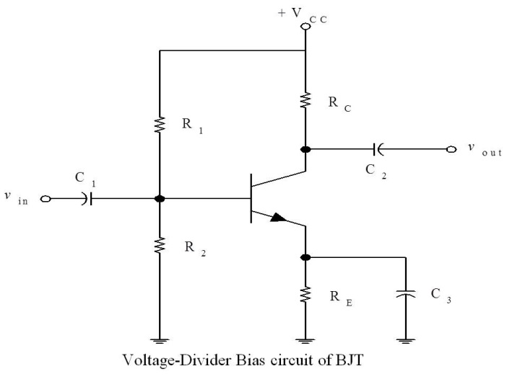----1M
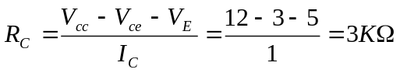 --- 1M
Given Ic=1mA,VBE=0.7,VCE=3V.VE=5V
Assume Ic₌ IE , 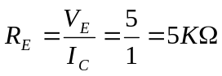 --- 1M
Let IR1=IR2=0.1 Ic=0.1mA R2=5.7V/0.1mA =57KΩ , R1=(12-5.7)V/0.1mA=63KΩ ---2M
2. Identify the following V-I characteristics and comment on operation of circuit used to get same.
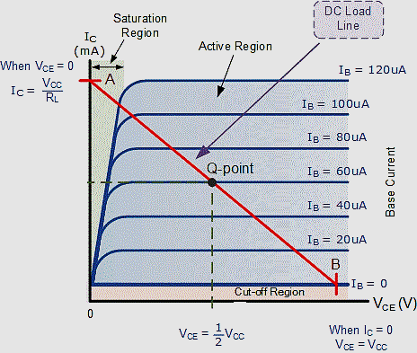
It is CE output charactersistics---1M
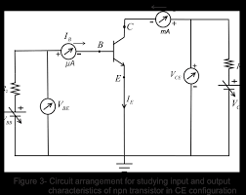---1M

To obtain output characteristics
- vBB is fixed so that Ib is fixed
- VCC is varied gradually from zero to its max value and value of VCE and Ic are noted
- The above steps are repeated fordifferent values of Ib ------3M

- Briefly explain the advantages of negative feedback amplifiers.
Some of the Advantages of negative feedback:
a) Bandwidth increases
b) Non linear distortion decreases
c) Frequency distortion decreases
d) Sensitivity will be decreased
e) Gain stability
The main disadvantage of negative feedback is decrease in overall gain. The gain and feedback factor in an amplifier are often functions of frequency, so the feedback may lead to positive feedback.

- With the help of a graph explain the frequency response of a BJT amplifier.
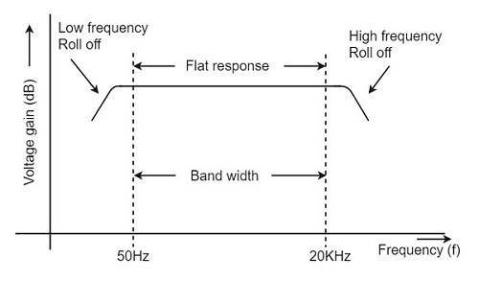
Frequency response curve is a graph that indicates the relationship between voltage gain and function of frequency. The frequency response of a RC coupled amplifier is as shown in the following graph. From the above graph, it is understood that the frequency rolls off or decreases for the frequencies below 50Hz and for the frequencies above 20 KHz. whereas the voltage gain for the range of frequencies between 50Hz and 20 KHz is constant.
We know that,
XC=1/2πfC
It means that the capacitive reactance is inversely proportional to the frequency.

At Low frequencies (i.e. below 50 Hz)
The capacitive reactance is inversely proportional to the frequency. At low frequencies, the reactance is quite high. The reactance of input capacitor C_{in}and the coupling capacitor C_{C} are so high that only small part of the input signal is allowed. The reactance of the emitter by pass capacitor C_{E} is also very high during low frequencies. Hence it cannot shunt the emitter resistance effectively. With all these factors, the voltage gain rolls off at low frequencies.

At High frequencies (i.e. above 20 KHz)
Again considering the same point, we know that the capacitive reactance is low at high frequencies. So, a capacitor behaves as a short circuit, at high frequencies. As a result of this, the loading effect of the next stage increases, which reduces the voltage gain. Along with this, as the capacitance of emitter diode decreases, it increases the base current of the transistor due to which the current gain (β) reduces. Hence the voltage gain rolls off at high frequencies.

At Mid-frequencies (i.e. 50 Hz to 20 KHz)
The voltage gain of the capacitors is maintained constant in this range of frequencies, as shown in figure. If the frequency increases, the reactance of the capacitor C_{C} decreases which tends to increase the gain. But this lower capacitance reactive increases the loading effect of the next stage by which there is a reduction in gain.Due to these two factors, the gain is maintained constant.

- Explain the working of RC coupled Amplifier.
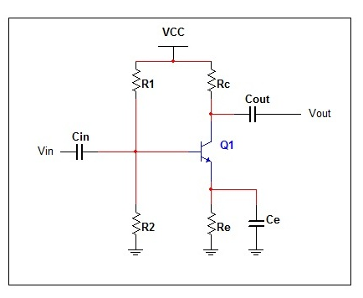
As you can see in the fig above, a coupling capacitor C_{C} is used to connect the output of first stage to the base i.e. input of the second stage and this continues when more stages are connected.
Since here the coupling from one stage to next is achieved by a coupling capacitor followed by a connection to a shunt resistor, therefore, such amplifiers are known as resistance-capacitance coupled amplifier or simply RC coupled amplifier.
The resistances R₁, R₂ and R_{E} form the biasing and stabilisation network.
The emitter bypass capacitor offers a low resistance path to the signal. Without this capacitor the voltage gain of each stage would be lost.
The coupling capacitor C_{C} transmits a.c. signal but blocks d.c. This prevents d.c. interference between various stages and the shifting of operating point
When a.c. signal is applied to the base of the first transistor, it is amplified and appears across its collector load R_{C.}
Now the amplified signal developed across R_{C} is given to the base of the next transistor through a coupling capacitor C_{C} .
The second stage again amplifies this signal and the more amplified signal appears across the second stage collector resistance.
In this way the cascaded stages amplify the signal and the overall gain is considerably increased.
- Explain the significance of gain sensitivity for an open loop system and a system with feedback.
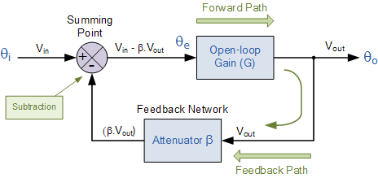
Feedback reduces the overall gain of a system with the degree of reduction being related to the systems open-loop gain. Negative feedback also has effectsof reducing distortion, noise, sensitivity to external changes as well as improving system bandwidth and input and output impedances.
- What are the advantages of negative feedback.
- Gain stability
- Bandwidth enhancement
- Improvement in linearity and signal handling capacity
- Noise reduction
- If the output power from an audio amplifier is measured at 10W when the signal frequency is 1kHz and 1W when the signal frequency is 10kHz. Calculate the dB change in power.

Solution:

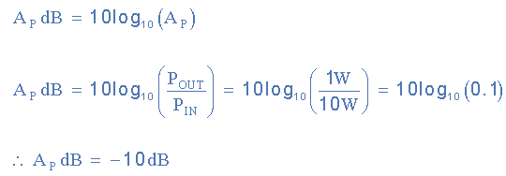

- If an electronic system produces a 24mV output voltage when a 12mV signal is applied, calculate the decibel value of the systems output voltage.

Solution:
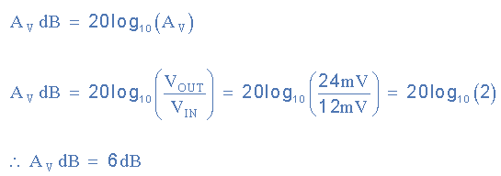
- The gain of the amplifier is 40. If positive feedback is introduced with gain of 0.025 estimate the gain of the amplifier with feedback. Also estimate gain of the amplifier with feedback If negative feedback is introduced with gain of 0.025

Av=infinite with positive feedback. Unstable.
Av=A/1+AB=20 with negative feedback.
- An amplifier has a bandwidth of 500Khz and voltage gain of 100.What should be the amount of negative feedback if the bandwidth is extended to 5Mhz?What will be the new gain after negative feedback is introduced?

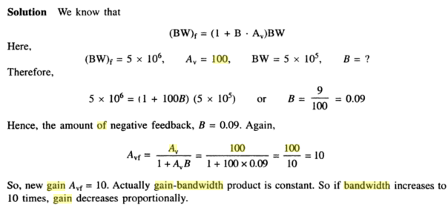
- An amplifier has midband gain of 125 and a bandwidth of 250KHz. i. If 4% negative feedback is introduced, find the new bandwidth and gain ii. If bandwidth is restricted to 1MHz, find the feedback ratio.
Solution:
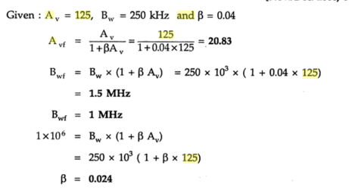
- Analyze the following graph and explain its significance.
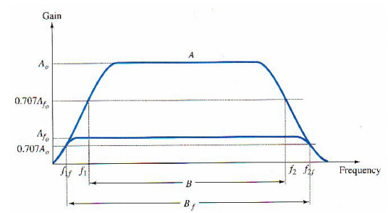

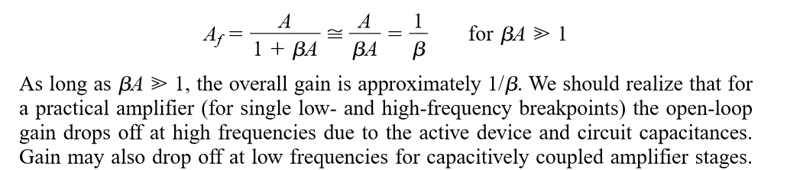 The feedback amplifier has a higher upper 3-dB frequency and smaller lower 3-dB frequency. It is interesting to note that the use of feedback, while resulting in a lowering of voltage gain, has provided an increase in B and in the upper 3-dB frequency particularly. In fact, the product of gain and frequency remains the same so that the gain– bandwidth product of the basic amplifier is the same value for the feedback amplifier. However, since the feedback amplifier has lower gain, the net operation was to trade gain for bandwidth

