JUNIT TESTING
A JUnit test is a method contained in a class which is only used for testing. This is called a Test class. To define that a certain method is a test method, annotate it with the @Test annotation. This method executes the code under test. You use an assert method, provided by JUnit or another assert framework, to check an expected result versus the actual result. These method calls are typically called asserts or assert statements. You should provide meaningful messages in assert statements. That makes it easier for the user to identify and fix the problem. This is especially true if someone looks at the problem, who did not write the code under test or the test code.

JUnit Assert Methods
- This class provides a number of assertion methods, which are useful for writing the test cases. We are recording only failed assertions by using this method. In JUnit, all the assertions contain the assert class.
- At the time of testing applications by using assert methods we are using the fail method to test the application.

Methods to assert Test results
1 | assertEquals(expected, actual) | Tests that expected, actual results are the same
2 | assertTrue(boolean condition) | Checks that the boolean condition is true
3 | assertFalse(boolean condition) | Checks that the boolean condition is false.

JUNIT TESTING USING ECLIPSE:
Step 1: Files New Java Project
Give the Project name as “Myclass1” and Select Project layout as “Use project folder as root for sources and class files”
Click Next and Click Finish
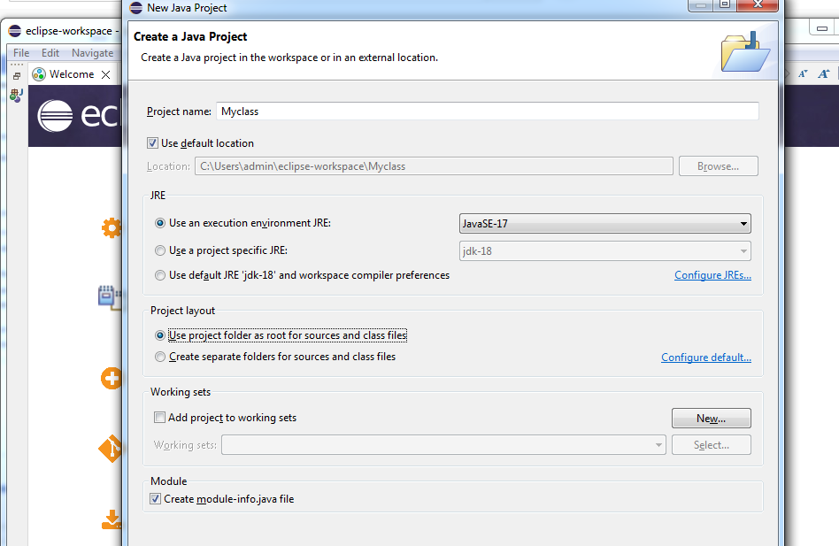
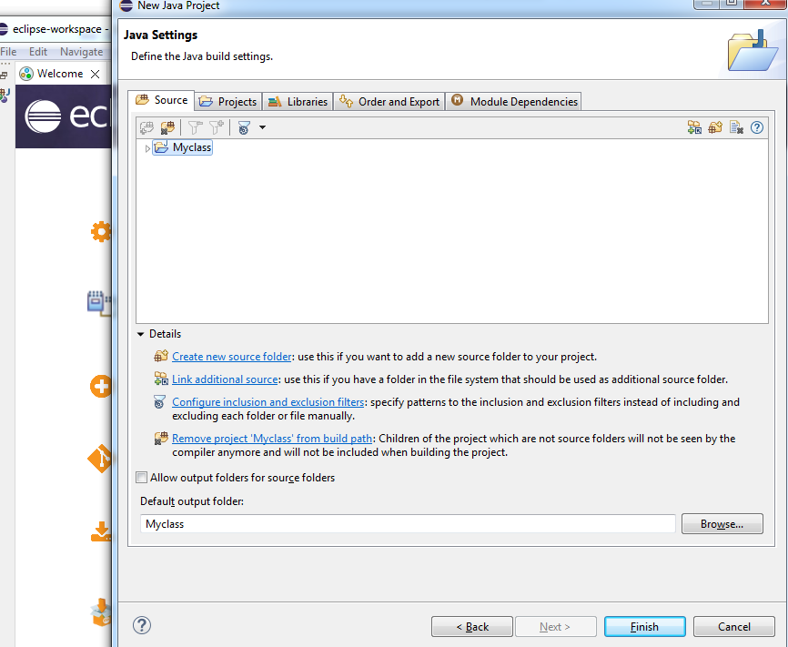
Step 2: Right click project i.e “Myclass1” New package
Give the package name as “ProgrammingKnowledge”
Click finish
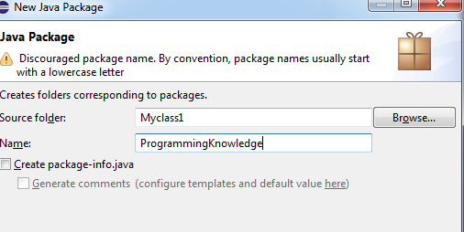
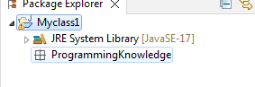

Step 3: Right click on package ”Programmingknowledge” New Class
Give the classname as ”MyJunitClass”
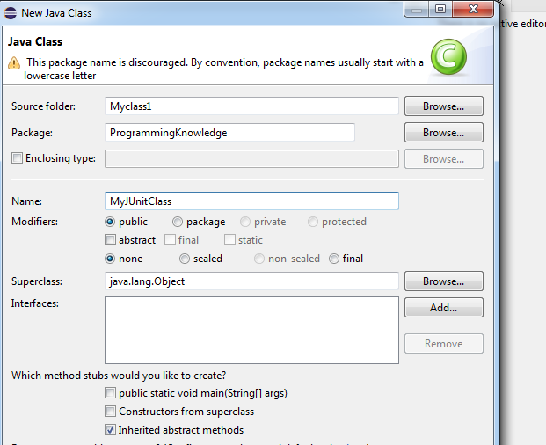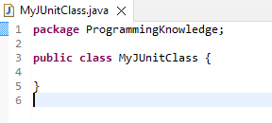
Step 4:
Write the following functions
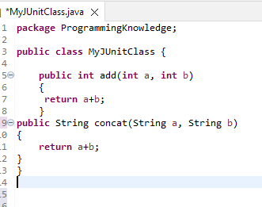

Step 5: Right click on Myclass1New Junit Test Case
Give the name as “MyclassJUnitTestcases” Click on finish then ok
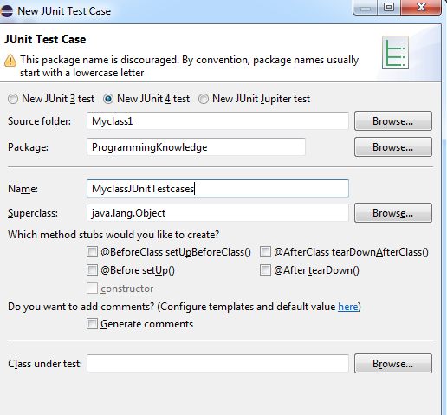
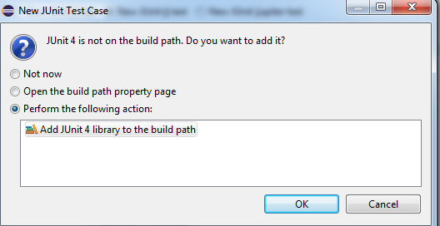

Following java files are created after step 5
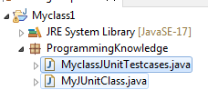

Step 6:
Click on MyclassJUnitTestcases.java and Update the code:
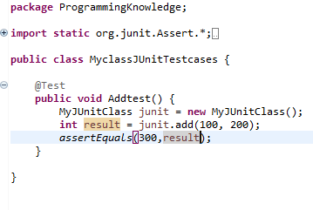
Right Click on MyclassJUnitTestcases.java Debug as Select Junit Test
Click ok
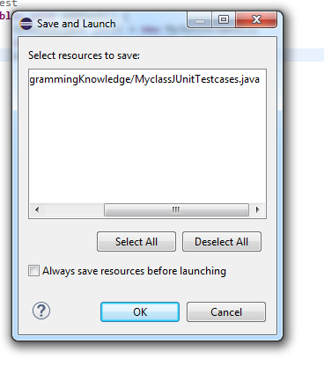
Junit Result as below
SUCCESS CASE
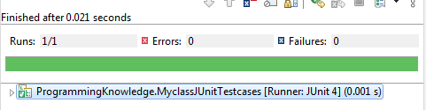
Failure Case
Update expected result with wrong value as shown below
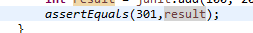
Right Click on MyclassJUnitTestcases.java Debug as Select Junit Test
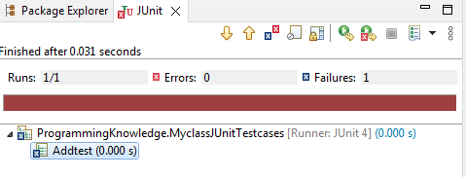

Step 7:
Repeat Step 5 for String concat
Right click on Myclass1New Junit Test Case
Give the name as “Myclassconcat” Click on finish then ok
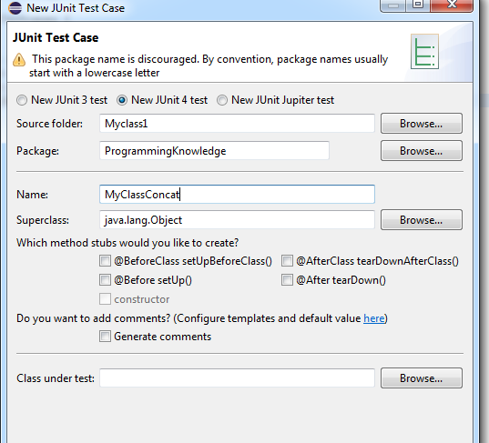
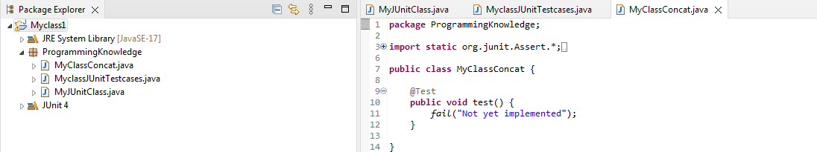

Step 8:
Update the code to concat two strings as below:
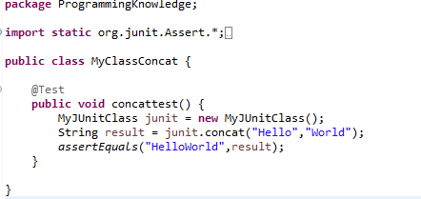

assertEquals
The assertEquals assertion verifies that the expected and actual values are equal

Right Click on Myclassconcat.java Debug as Select Junit Test
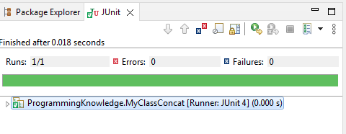
Step 9: Create test suite for both add and concat cases
Right click on Myclass New other Under Junit Select Junit Test Suite
Click finish
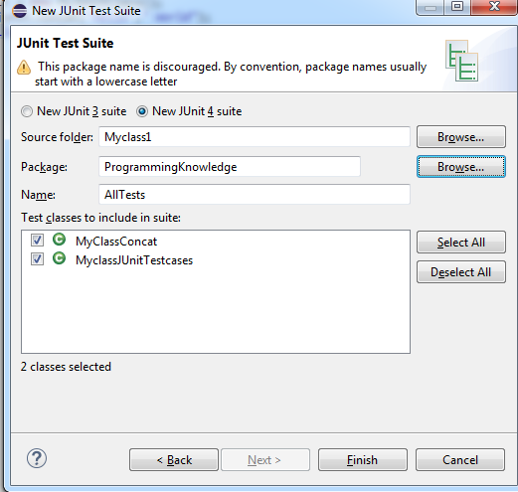
AllTests.java gets created
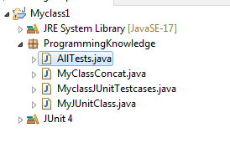
Right click on AllTests.java Debug As Select Junit Test
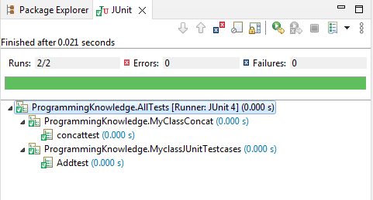
https://www.youtube.com/watch?v=tkzJsP7NP54
assertTrue() method checks if supplied boolean condition is true. In case, condition is false, it will through AssertError.
- public static void assertTrue(boolean condition)
- public static void assertTrue(boolean condition, Supplier messageSupplier)

1. public static void assertTrue(boolean condition)
Under Step-4 In MyJUnitClass.java add the below function
public boolean isPrime(int number)
{
for (int i = 2; i <=Math.sqrt(number); i++) {
if(number%i==0)
return false;
}
return true;
}
Repeat Step 5 for isPrime
Right click on Myclass1New Junit Test Case
Give the name as “AssertTrueEx” Click on finish then ok

Update the code to test function as below:
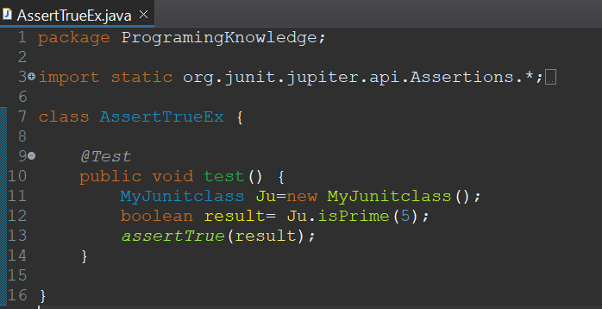
Right Click on AssertTrueEx.java Debug as Select Junit Test
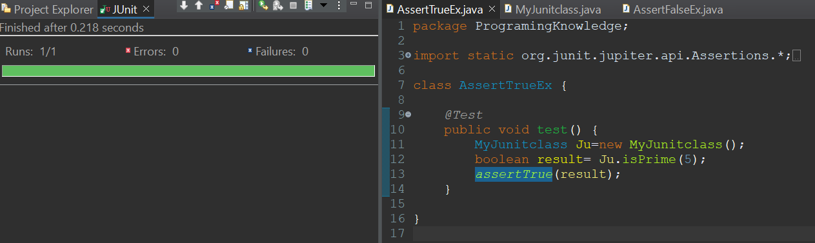
Input passed through the calling function is prime hence it return true, As it returns true, executed testcase will be pass.

2. public static void assertTrue(boolean condition, Supplier messageSupplier)
If we use above method by passing some message as second parameter, it displays the message in case of test failure.
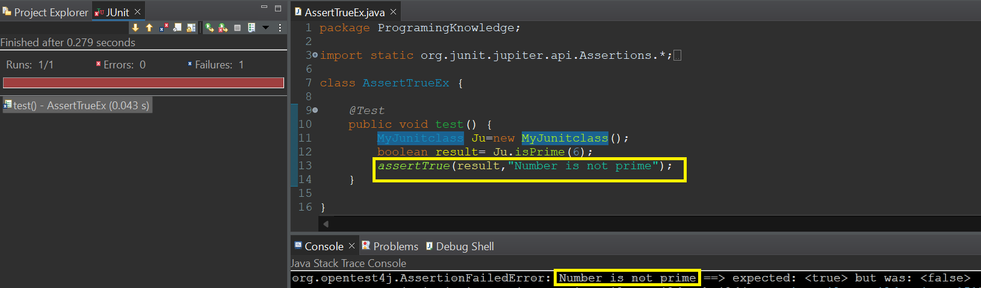
number passed through the isPrime function is not a prime number, Hence function returns false. As it returns false , executed testcase will be fail.

assertFalse – AssertFalse() checks if supplied boolean condition is false. In case, condition is true, it will through AssertError.
- public static void assertFalse(boolean condition)
- public static void assertFalse(boolean condition, Supplier messageSupplier)

1. public static void assertFalse(boolean condition)
Under Step-4 In MyJUnitClass.java add the below function
public boolean isPalindrome(String str)
{
for (int i = 0,j=str.length()-1; i <str.length()/2; i++,j--) {

if(str.charAt(i)!=str.charAt(j))
{
return false;
}
}
return true;
}

Repeat Step 5 for isPalindrome
Right click on Myclass1New Junit Test Case
Give the name as “AssertFalseEx” Click on finish then ok

Update the code to test function as below:
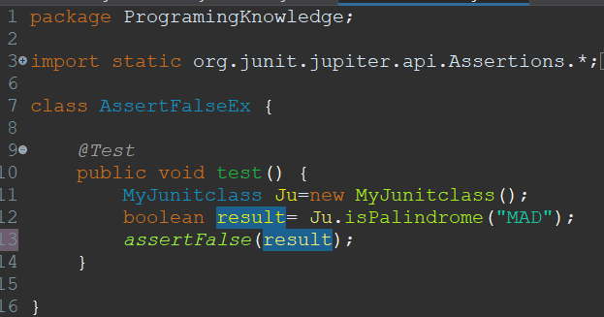

Right Click on AssertFalseEx.java Debug as Select Junit Test
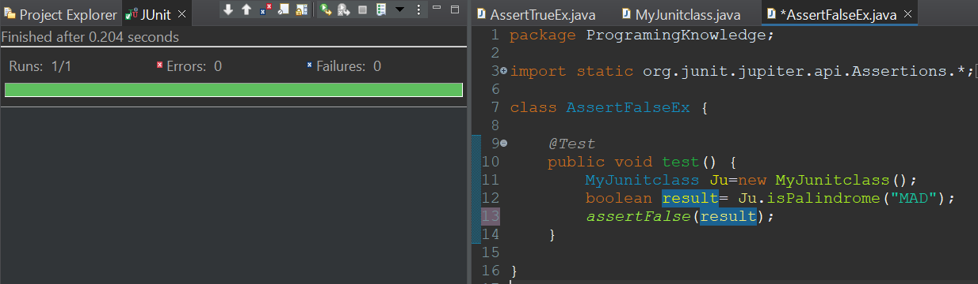
string passed through the isPalindrome function is not a palindrome, hence function returns false. As it returns false , executed testcase will be pass.
2. public static void assertFalse(boolean condition, Supplier messageSupplier)
string passed through the isPalindrome function is a palindrome, Hence function returns true. As it returns True, executed testcase will be fail and also it displays the message which has passed through the assertFalse Function.
