Q.1 Prepare a class diagram from the object diagram in Figure below.

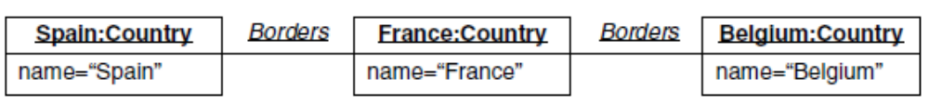

Fig. Object diagram for a portion of Europe
Sol:
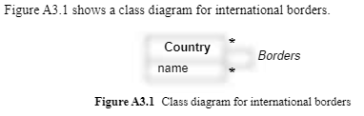

Q.2 Prepare a class diagram from the object diagram in Figure below. Explain your multiplicity
decisions. Each point has an x coordinate and a y coordinate. What is the smallest number of
points required to construct a polygon? Does it make a difference whether or not a point may
be shared between polygons? Your answer should address the fact that points are ordered.

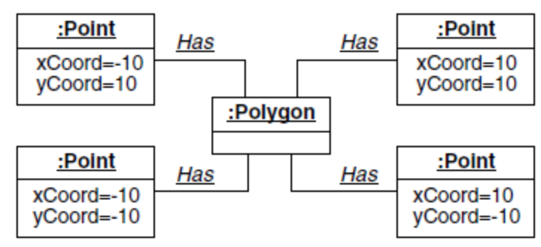

Fig. Object diagram for a polygon that happens to be a square

Sol: Figure below shows a class diagram for polygons and points. The smallest number of points required to construct a polygon is three. The multiplicity of the association depends on how points are identified. If a point is identified by its location, then points are shared and the association is many-to-many. On the other hand, if each point belongs to exactly one polygon, then several points may have the same coordinates.

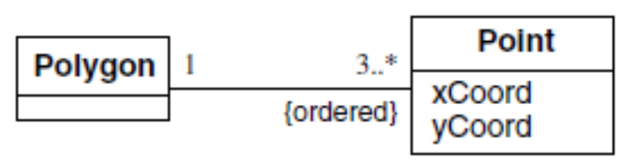
Fig. Class diagram for polygon and points

Q.3 Using your class diagram for question 2, prepare an object diagram for two triangles with
a common side under the following conditions.
a. A point belongs to exactly one polygon.
b. A point belongs to one or more polygons.

Sol:
(a) Figure below shows objects and links for two triangles with a common side in which a point
belongs to exactly one polygon.

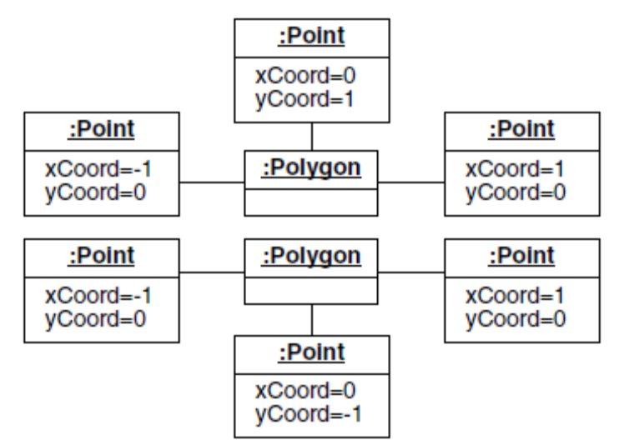

Fig. Object diagram where each point belongs to exactly one polygon

b) Figure below shows objects and links for two triangles with a common side in which points may be shared.

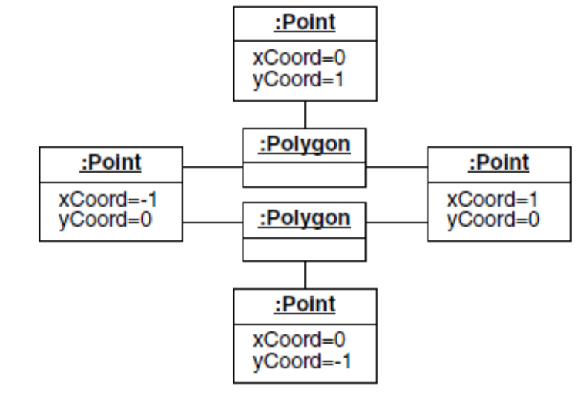

Fig. Object diagram where each point can belong to multiple polygons

Q.4 Prepare a class model to describe undirected graphs. An undirected graph consists of a set
of vertices and a set of edges. Edges connect pairs of vertices. Your model should capture only the structure of graphs (i.e., connectivity) and need not be concerned with layout such as location of vertices or lengths of edges. Figure below shows a typical undirected graph.

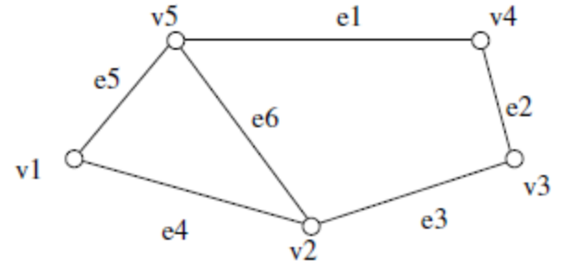
Fig. Sample undirected graph

Sol: Graphs occur in many applications. Several variations of the model are possible, depending on your viewpoint. Figure below accurately represents undirected graphs as described in the exercise. Although not quite as accurate, your answer could omit the class UndirectedGraph.

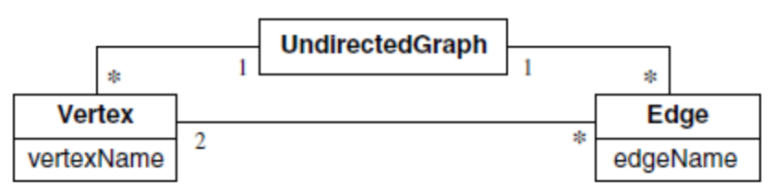

Fig. class diagram for undirected graph

We have found it useful for some graph related queries to elevate the association between vertices and edges to the status of a class as Figure below shows.

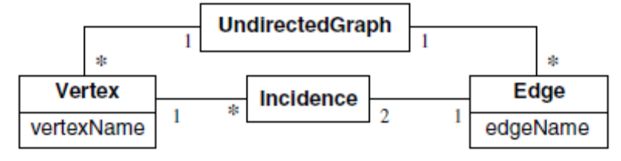

Fig. Class diagram for undirected graphs in which the incidence between
vertices and edges is treated as a class

Q.5 Prepare a class model to describe directed graphs. A directed graph is similar to an undirected graph, except the edges are oriented. Figure below shows a typical directed graph.

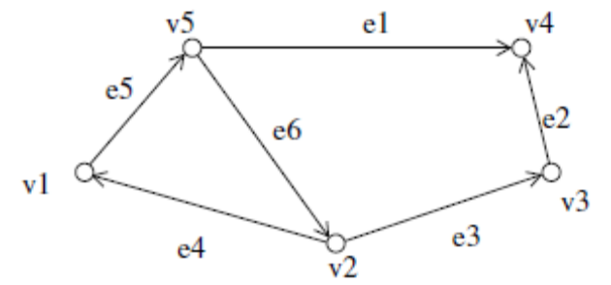

Fig. Sample directed graph

Sol: Figure A3.27 shows a class diagram describing directed graphs.The distinction between the
two ends of an edge is accomplished with a qualified association. Values of the qualifier end
are from and to.

Figure A3.28 shows another representation of directed graphs. The distinction between the
two ends of an edge is accomplished with separate associations.

